Selenium Automation with Hybrid Framework

URL: <https://www.youtube.com/watch?v=M4Ye3SKT46g>

Github url:

<https://github.com/pavanoltraining/inetbankingV1>

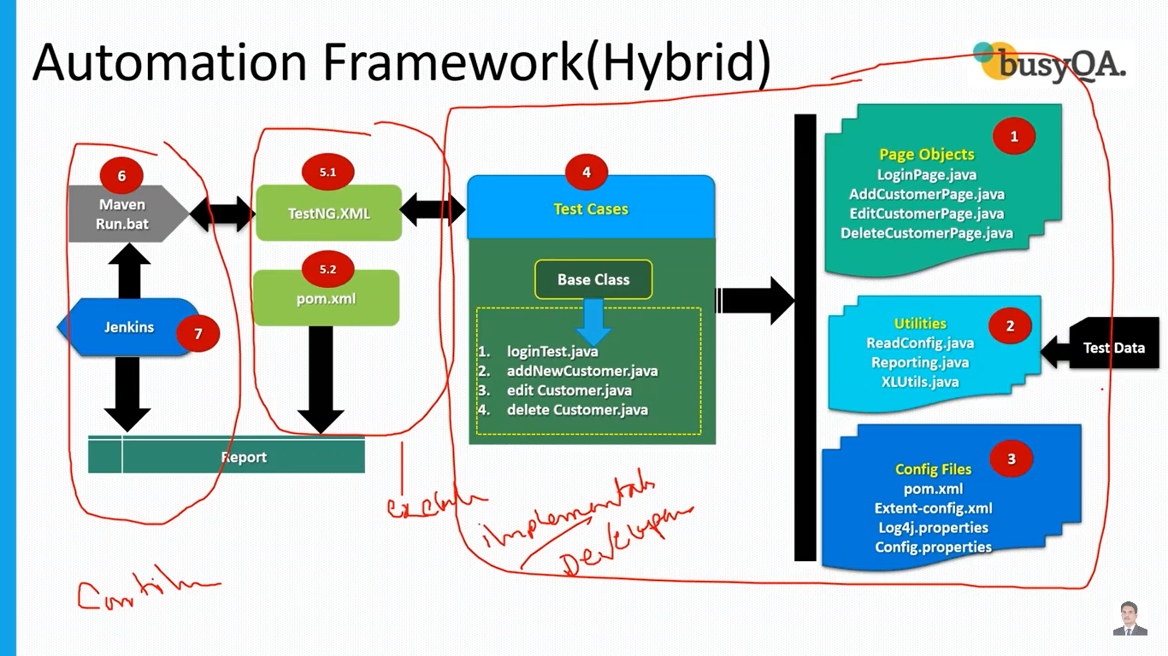

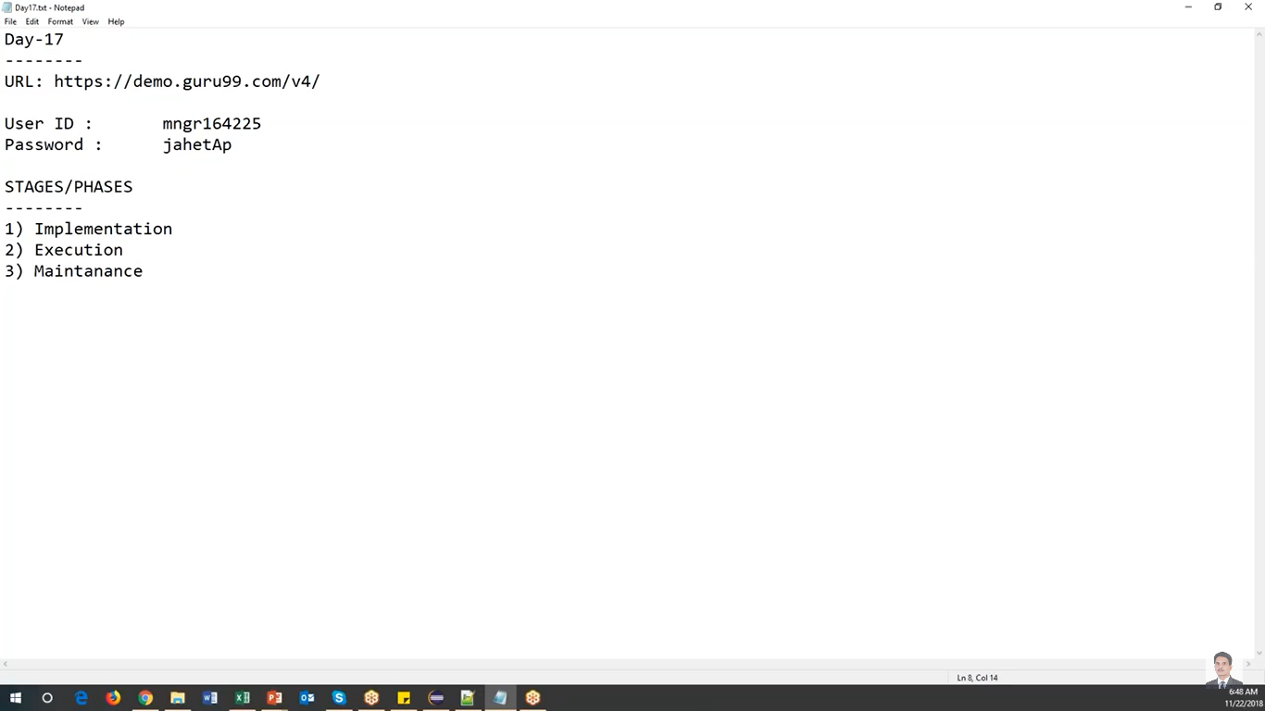

One time job to create below

Phase -1: Implementation

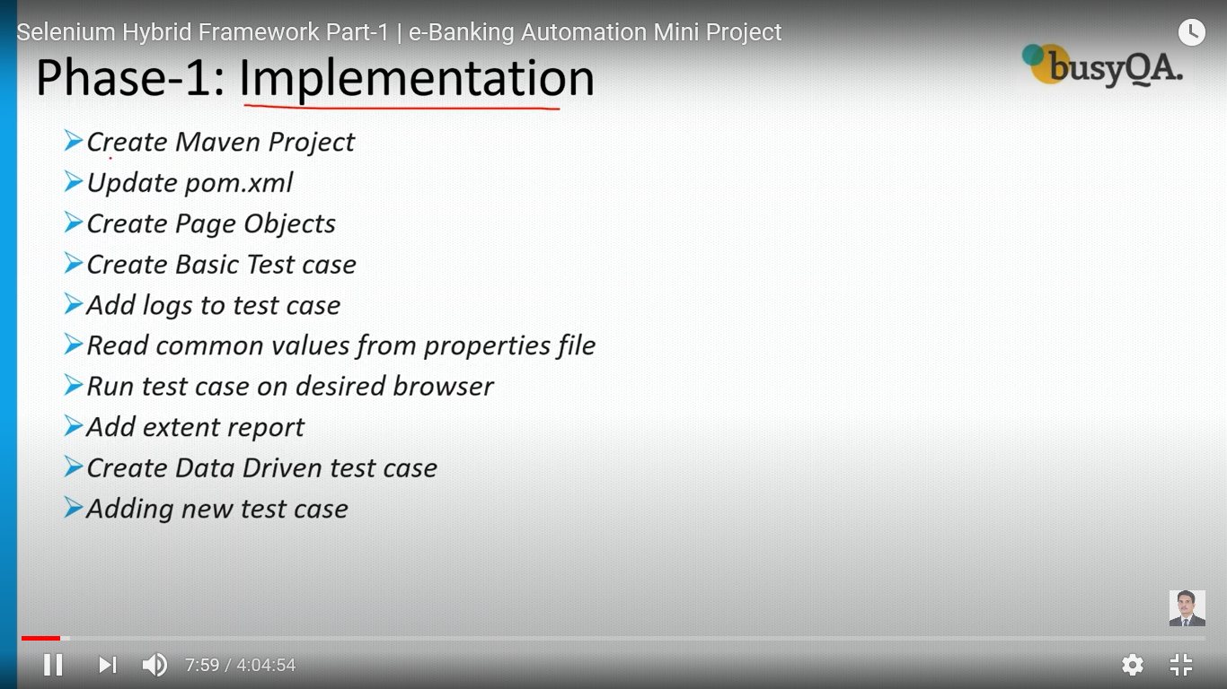

Exercise- 2:Execution

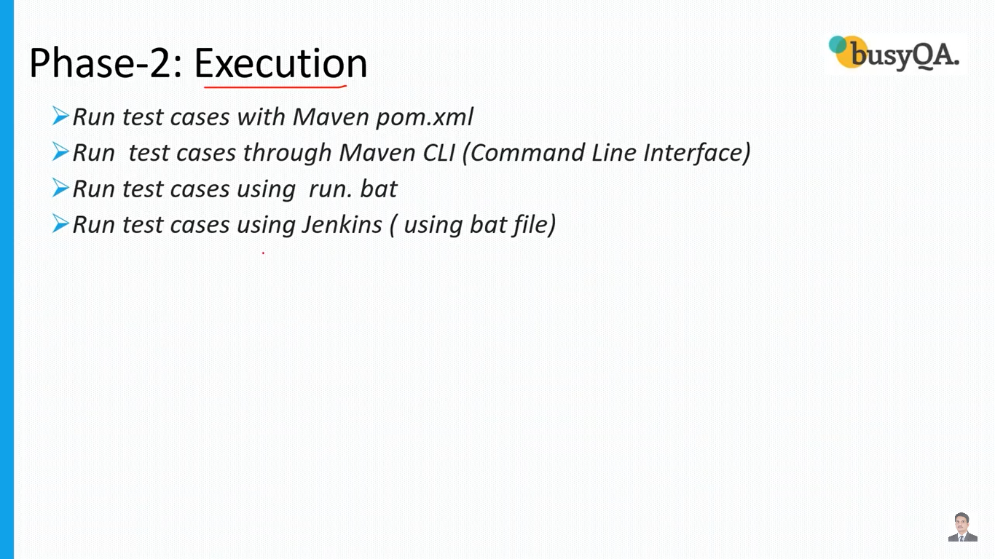

Phase- 3: Execution:



Framework-Hybrid

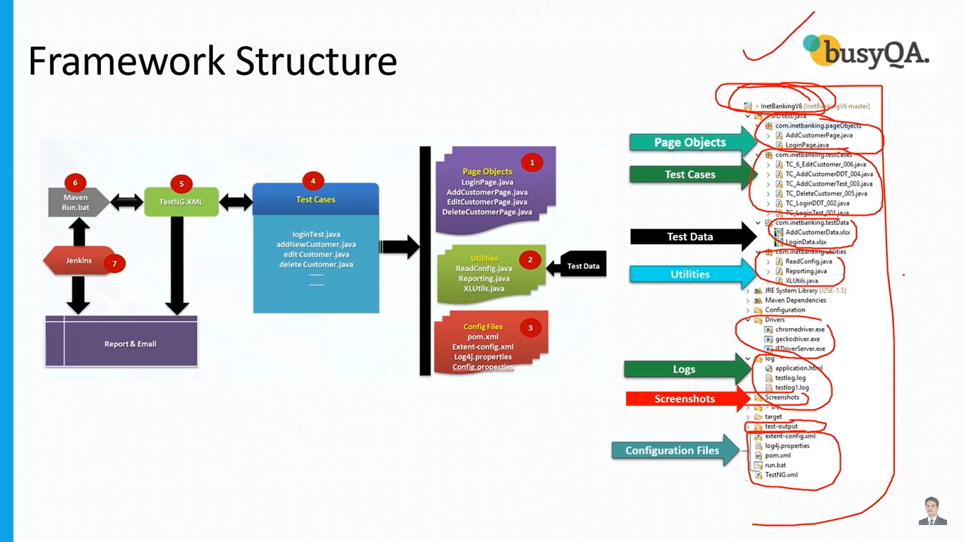

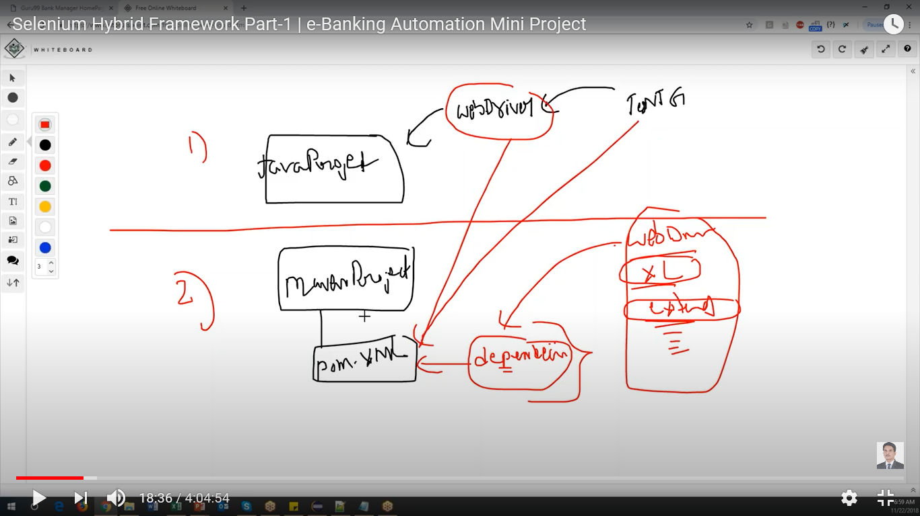

1. Create Maven Project

New-Other->Maven Project

Enter project name as HybridFramework in GroupID and ArtifatID and click finish

Select the default packages which are sated link Hybrid framework and delete

1. Update POM.XML file

Create folder structure like below

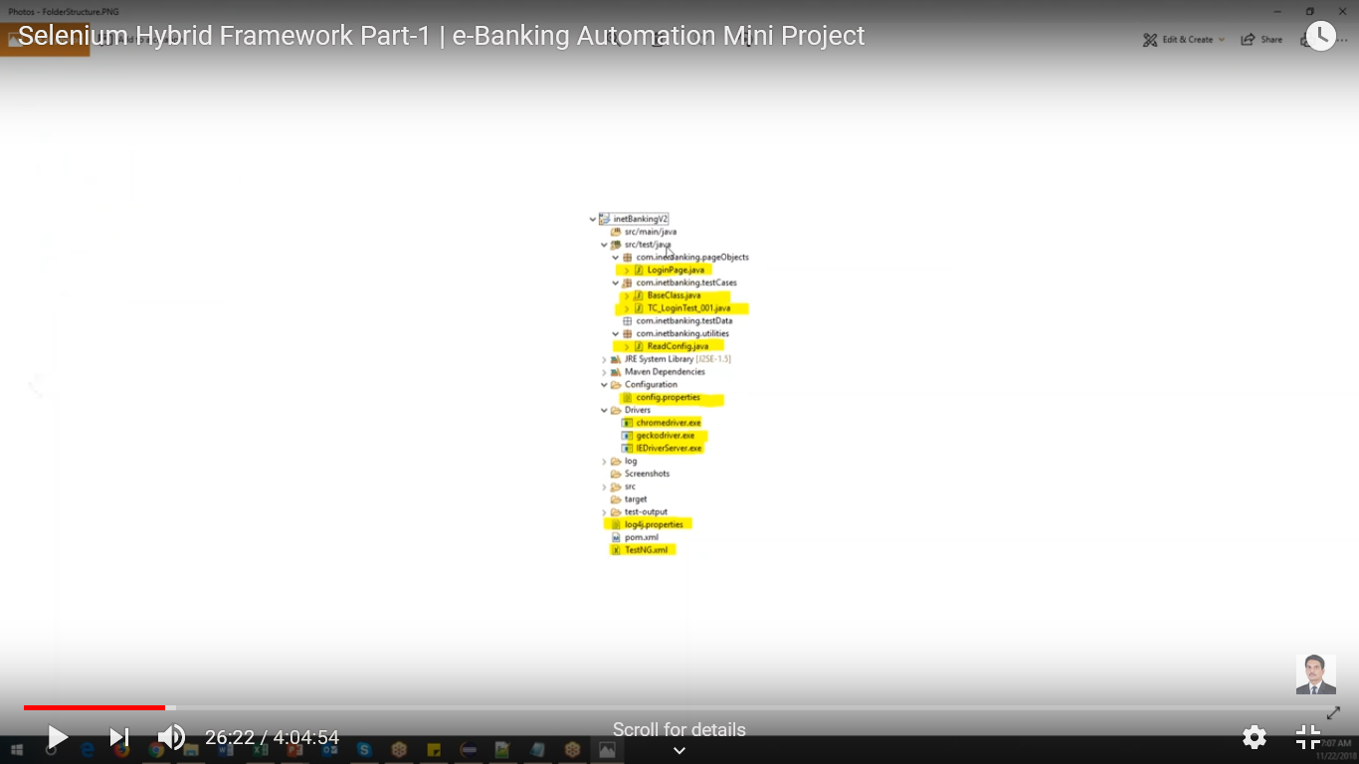

1,. Create package 1 with the name of “com.ccs.pageObjects”

Create one 2 more

“com.ccs.testCases”

“com.ccs.testData”

“com.ccs.utilities”

Packages:

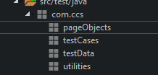

Create folder

Select project->New-Folder

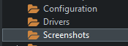

1. Update POM.XML

Following peace of code can’t be modified in POM.XML

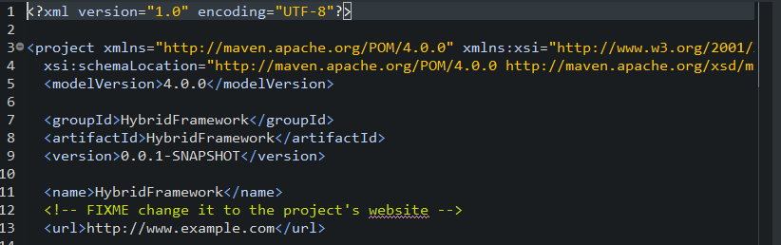

All the dependencies can be downloaded from <https://mvnrepository.com/>

Add below dependencies

selenium-java

testng

poi

poi-ooxml

extentreports

commons-lang3

1. Create PageObjects

Create class for login page like below

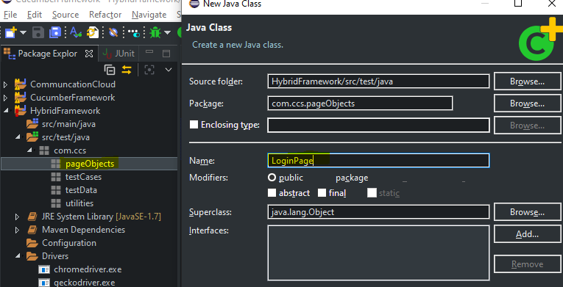

testCaes

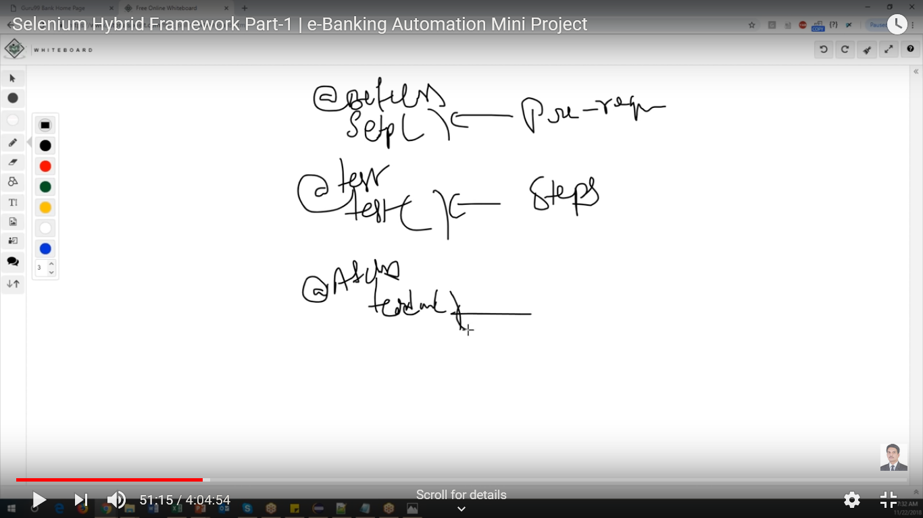

Before and After classes are common for all the test cases. So we will create a base class add setup and test classes

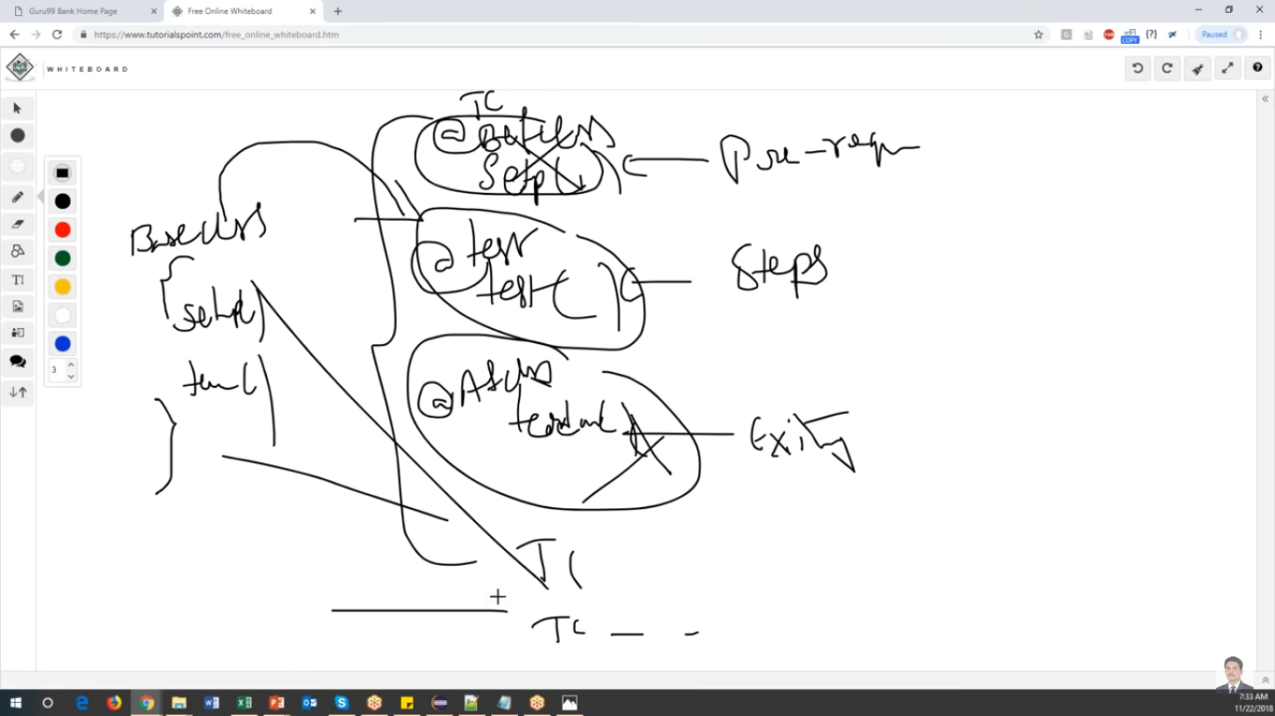

All common thng should be part of bases class. Suppose test case 1, Test case 2 and test cases are have some common

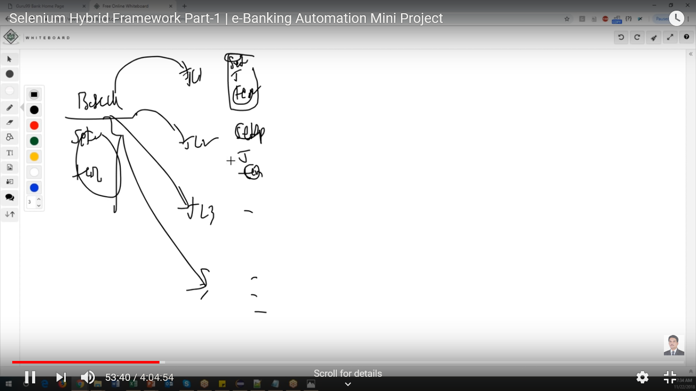

Select testCases and Create new class for test cases1

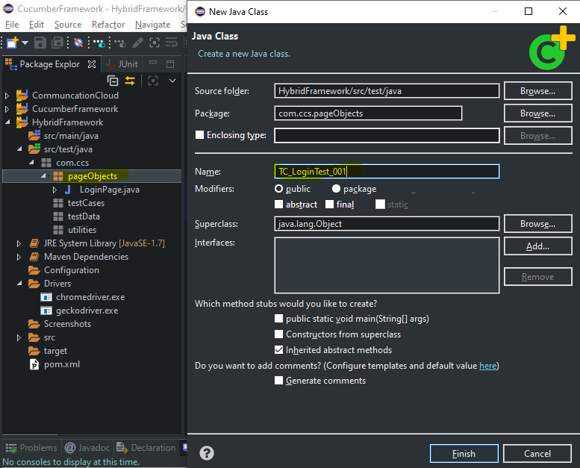

Select testCases->Create Base class

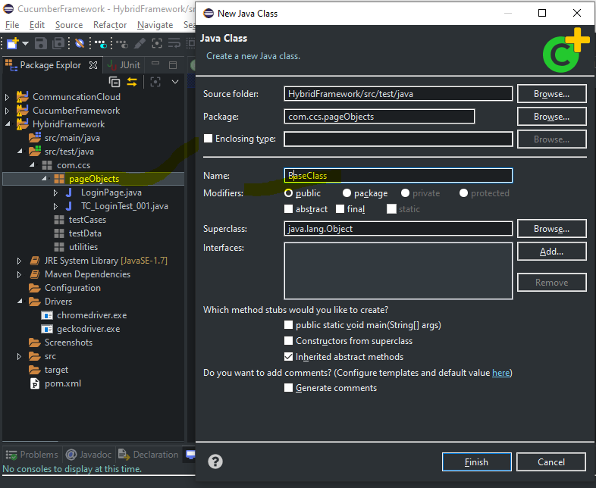

Go to the Mvnrepository.com and all the required Dependencies.

Add code to below clases

1. LoginPage.java
2. BaseClass.java
3. TC_LoginTest_001.java

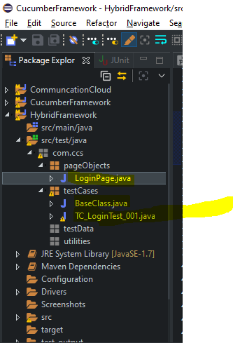

Runtest

Select TC_LoginTest_001.java and RunAs->TestNG Test

Result: launch the browser and loginto guru 99 page and validate with title name

1. Add logs to test cases-Implement LOG4J

Add log4j dependencices in POM.XML

Goto the <https://mvnrepository.com/> and search for [Apache Log4j](https://mvnrepository.com/artifact/log4j/log4j)

log4j

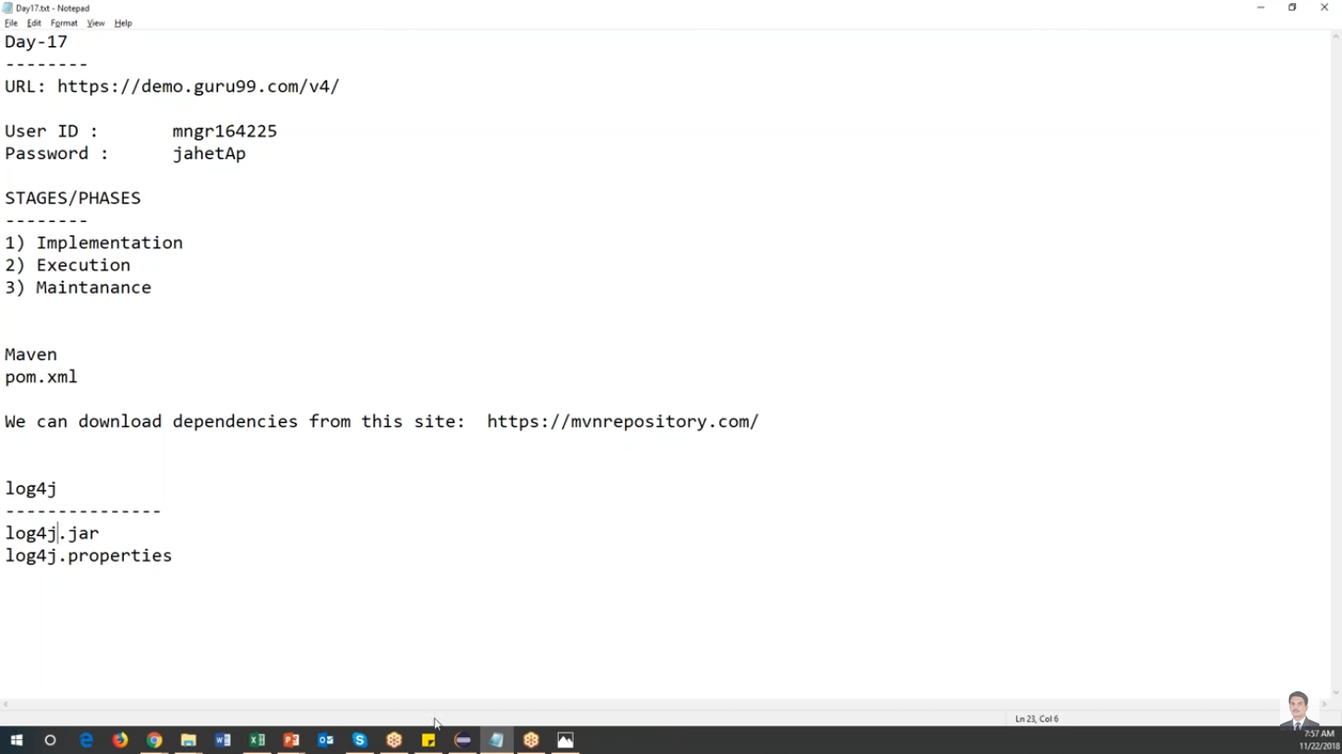

Copy the **log4j.properties** file into your project directory

Go to the baseClass.java

Create global variable for Logger

And add highlited below

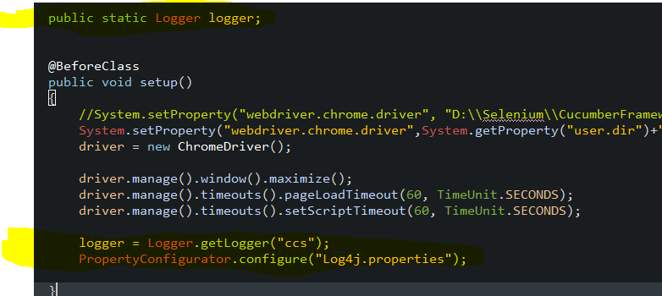

Import properties or copy the below

import org.apache.log4j.Logger;

import org.apache.log4j.PropertyConfigurator;

in test cases add log messages

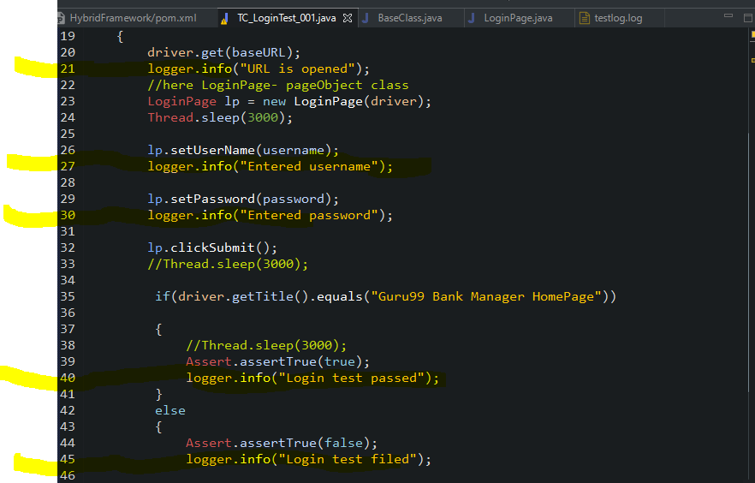

Run the test now

Select TC_testcase_001->Run As-?TestNG test

Once test run is passed, verify that all the logger info in test result in console.

Refres the project by selecting Refresh

Result : Log folder will be created under the project like below

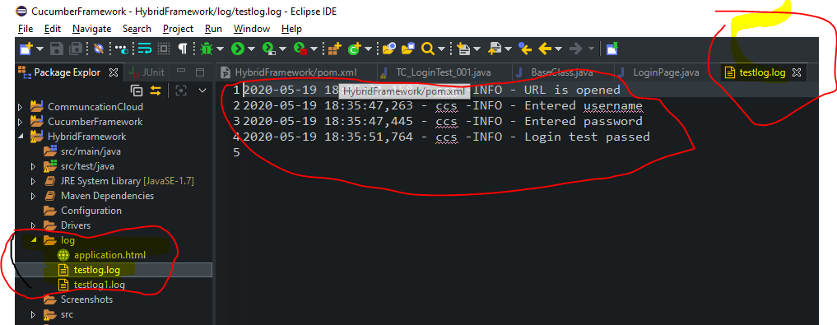

1. Read common values from property file.

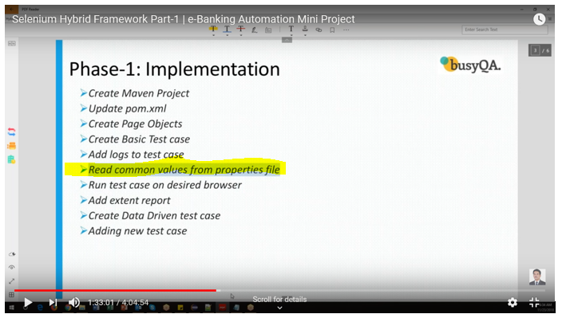

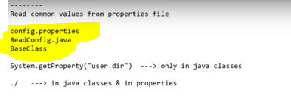

**Property file** is text file and which is contains all your text variables

In base class, in real time we should not hordcode like below.

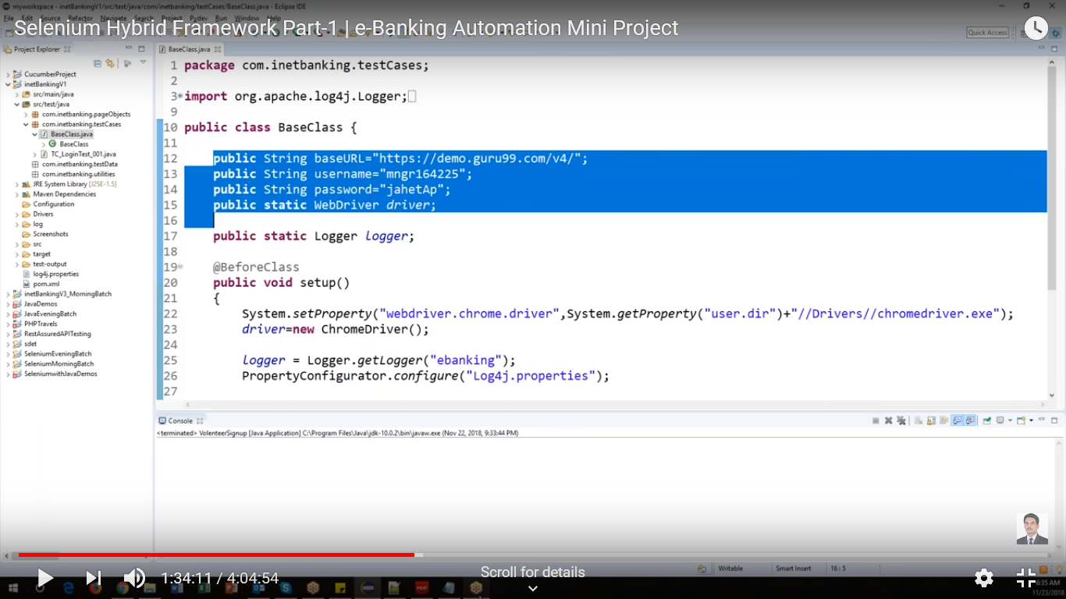

So to maintain all the veriables will create a common file called **config.properties** file

Then put all the values in **config.properties** file

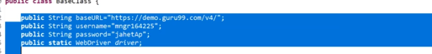

To read properties file will create **ReadConfig.java** file

1. Config file
2. Read file
3. Base class

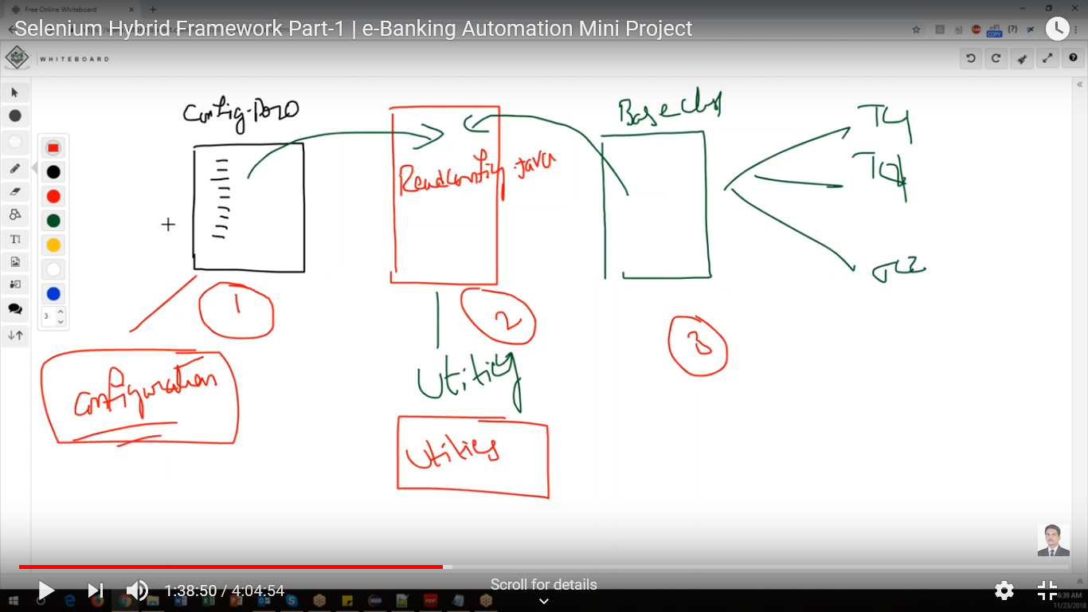

**Create config.properties file under Configuration folder**

Select configuration folder->New-File and enter file name as **config.properties**

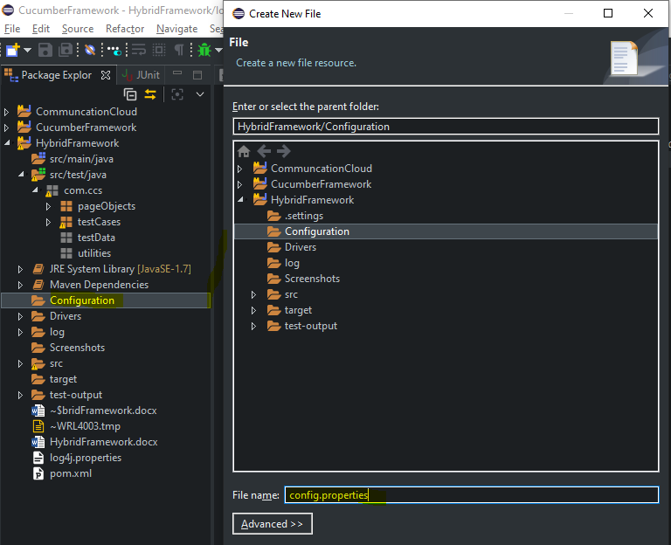

**Configurations**

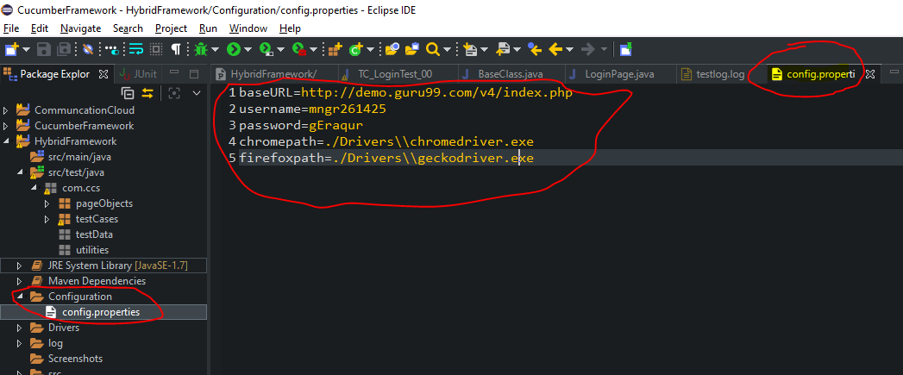

Create Utilities class with the name of **ReadConfig.java** under utilities package

Utilities->New->Class

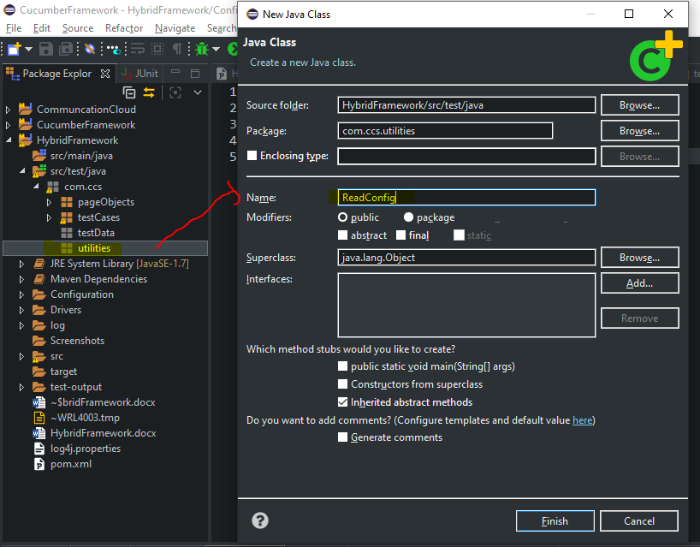

Create methods for each variable we declared in config.properties file

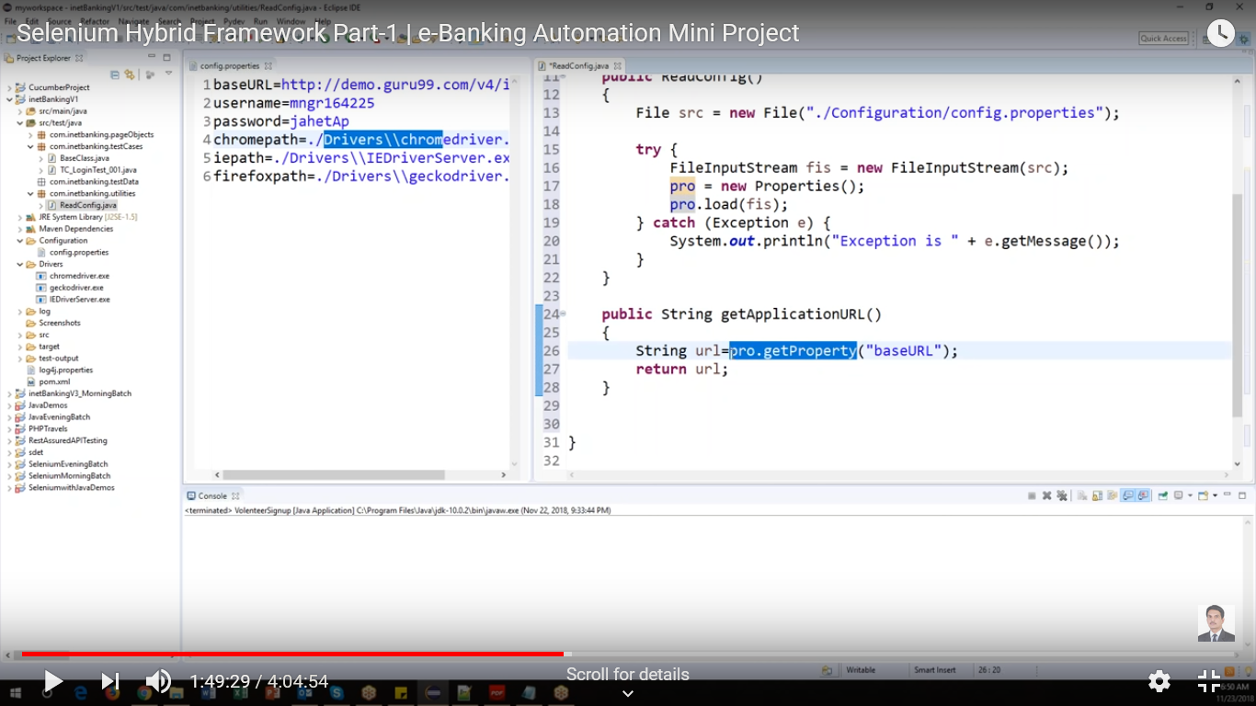

Communicate each other like below.

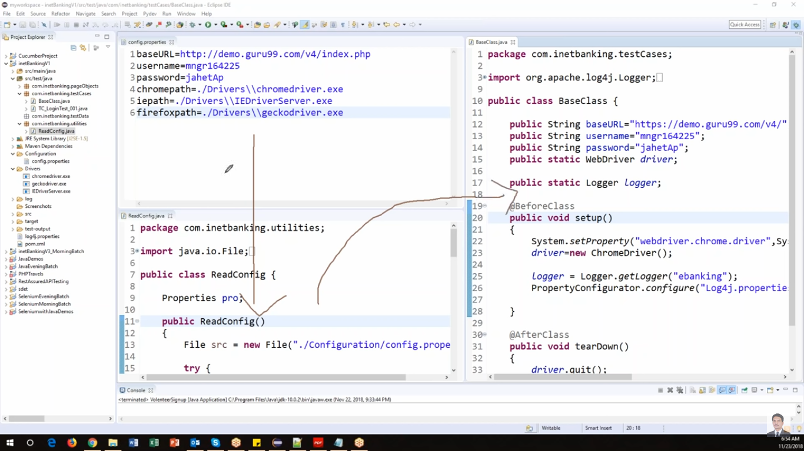

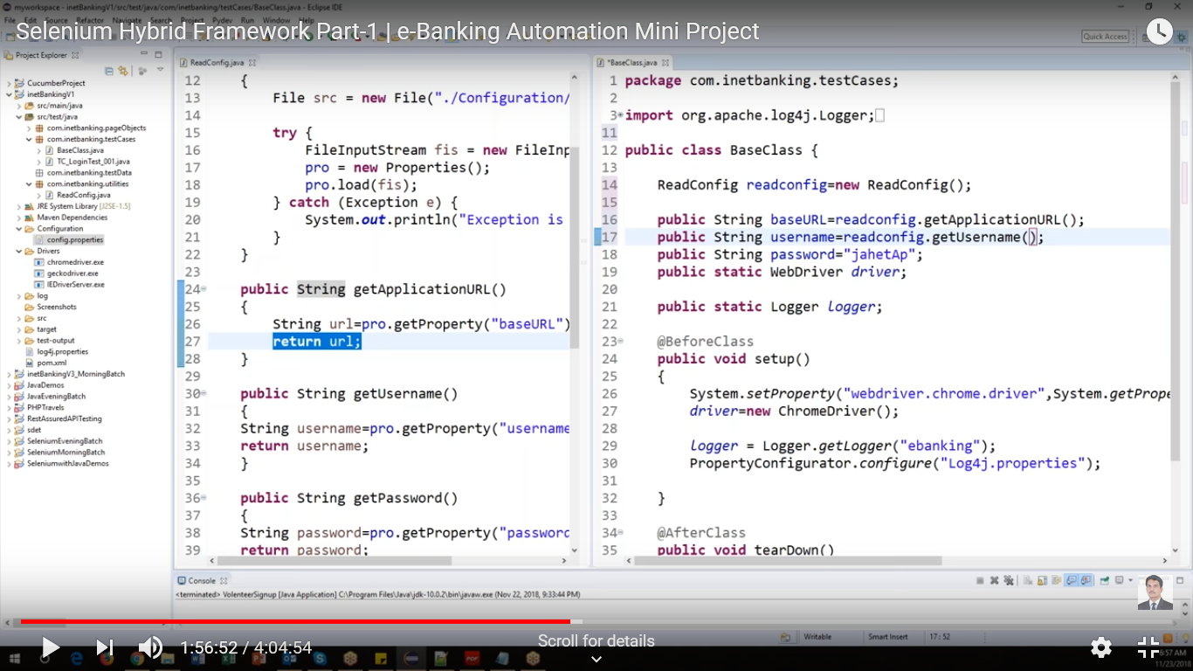

Call the methods in BaseClass.java which are declared in ReadConfig.java file

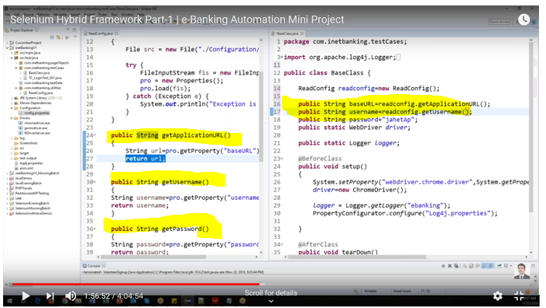

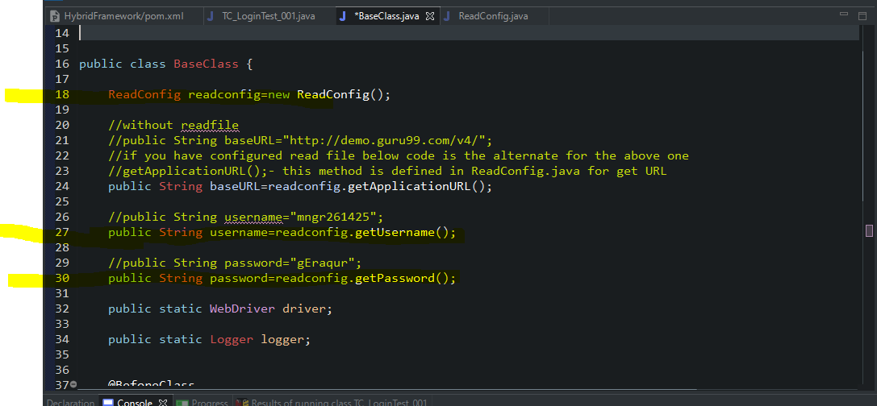

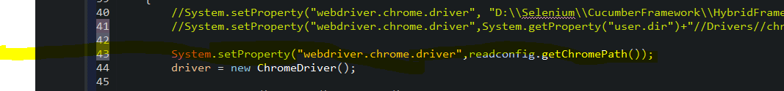

1. Run test case on desired browser

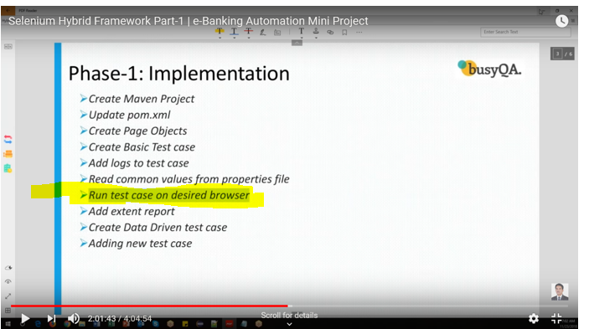

Add parameter in base class



Add string in @Before class

Use if else condition for the browsers

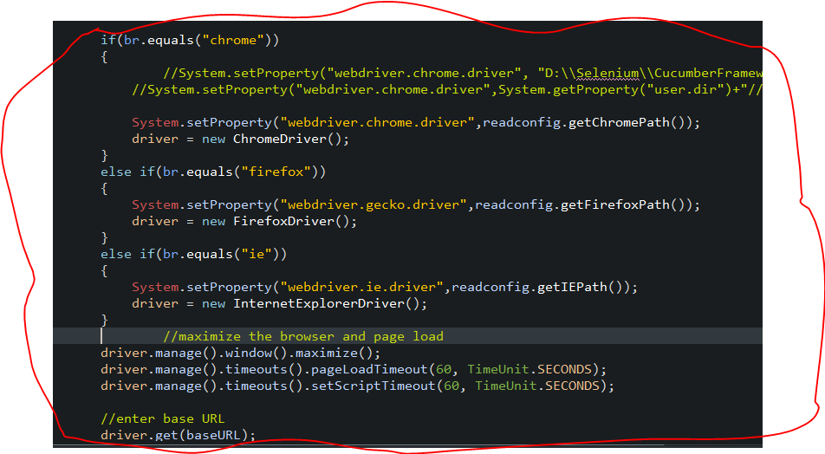

Delete the below code in TC_testcase_001 , beause we moved it into basesClass.java file



Next we have to create an xml file in project level

Select project->New->Other->Expand XML->select XML File->Next

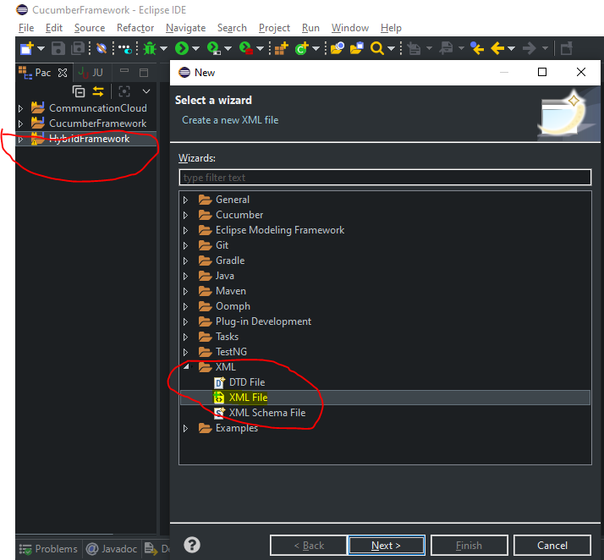

Next, give the file name as “**TestNG.xml**” and then finish

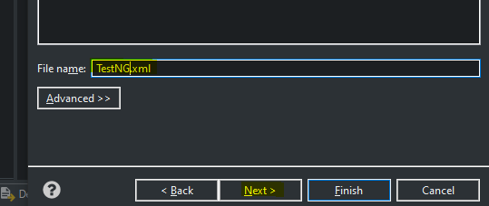

Add code like below in TestNG.xml

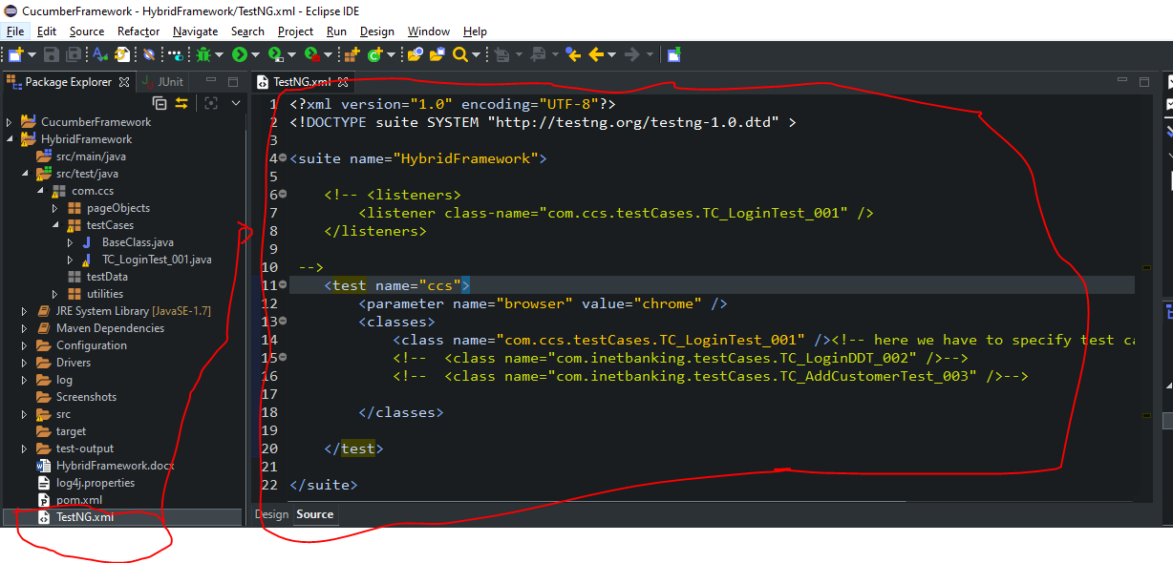

Here

 - Project Name

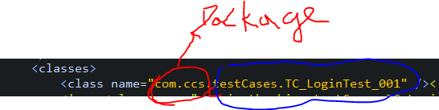

Packagename.TestcaseFolderName.TestCaseName

**Runtest:**

Select TestNG.xml->Run As->TestNG Test

**Result:** test case will run without erros in selected browser

1. **Add extent report**

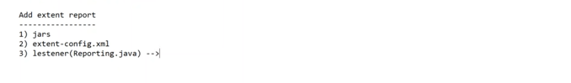

1. Jars in dependencies

Add extent report Dependencies in **POM.XML**

Extentreports

1. **Extent-config.xml** in Project folder
2. Create a new class “**Reporting.java**” in **utilities** package

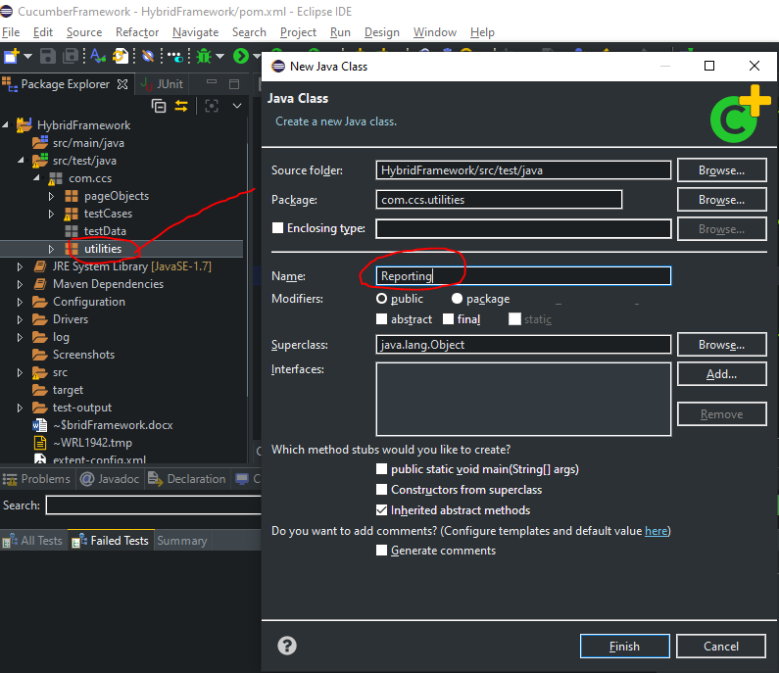

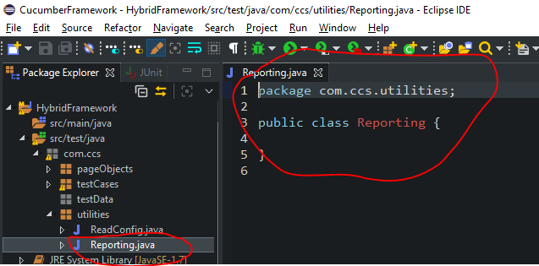

Specify test listener adapter class

New we have to integrate the utilities listener calls and Test cases usinf XML

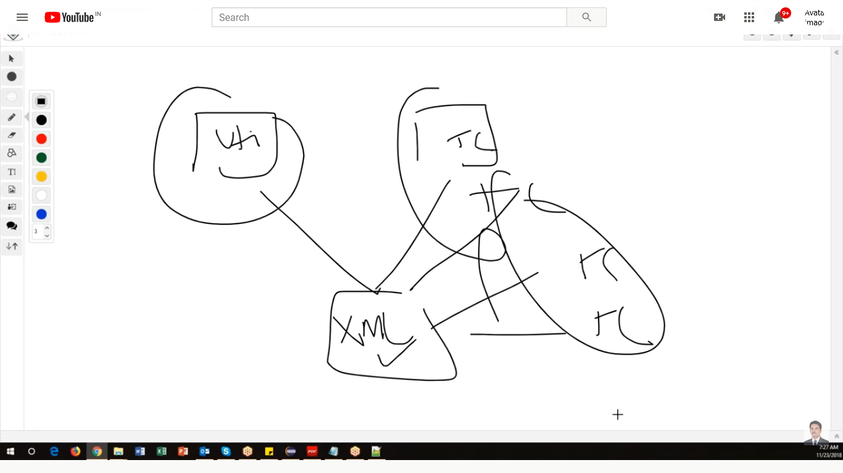

Add entry in testng.xml

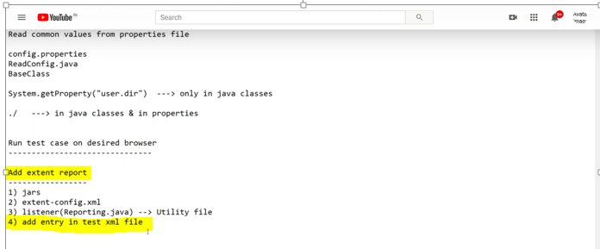

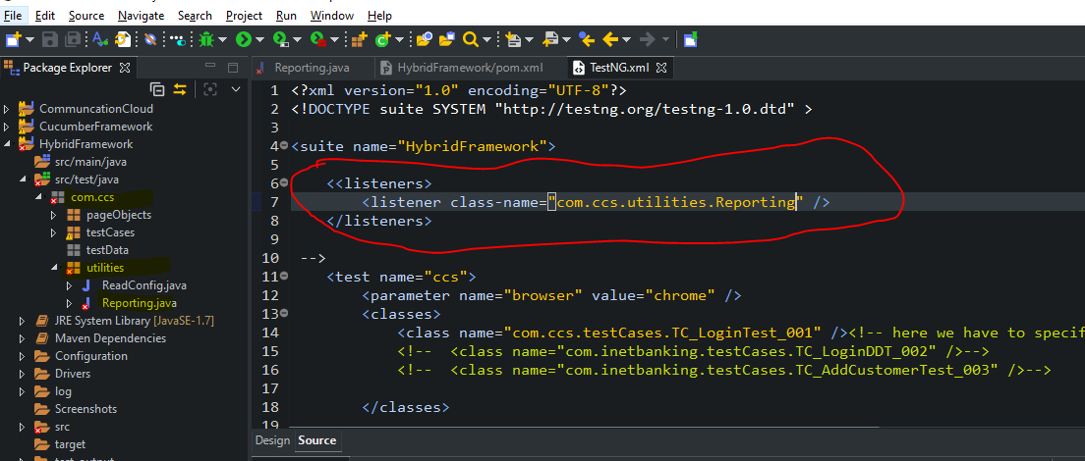

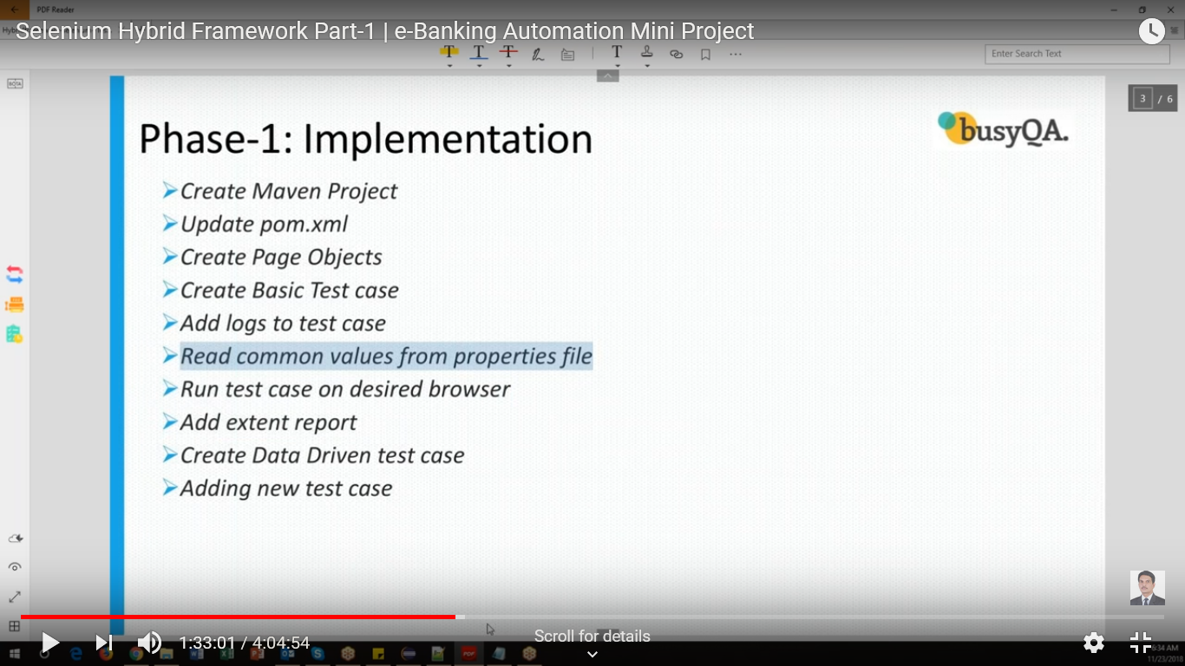

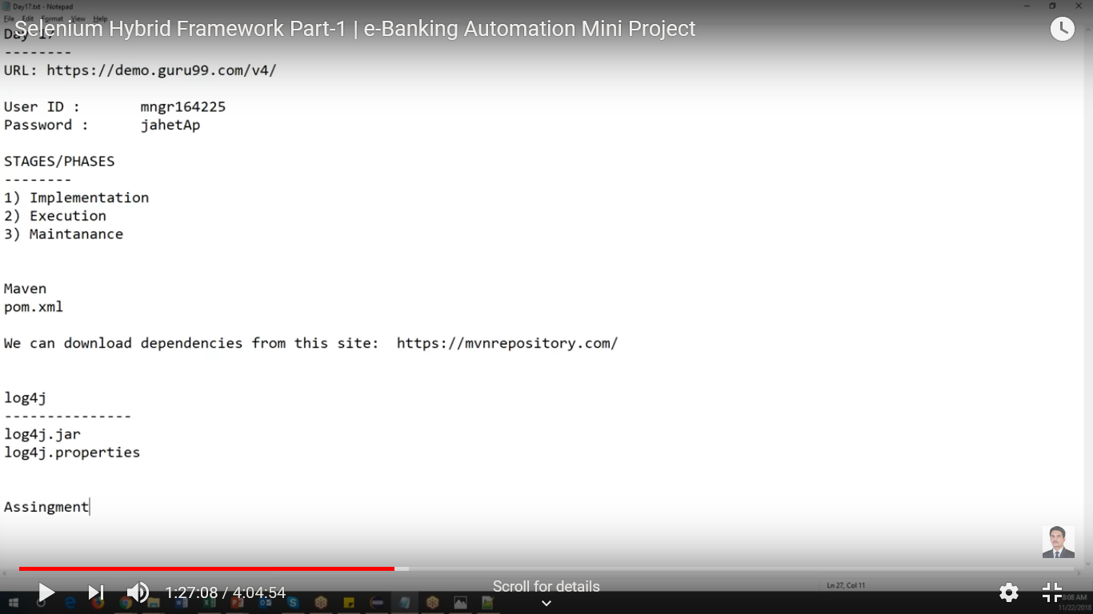

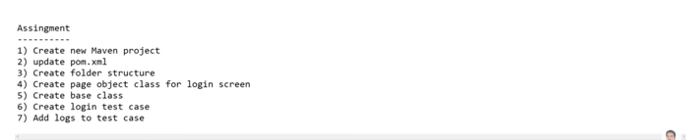

Add capturescreen method in basecalss

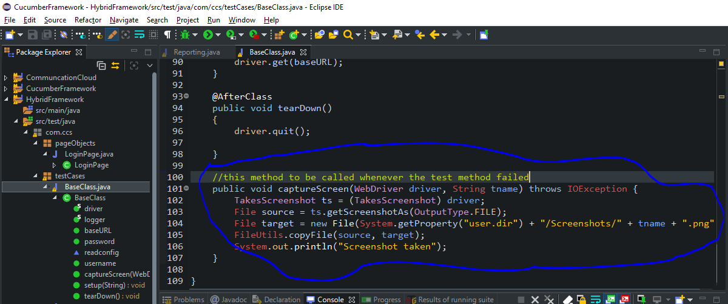

Call the method in TC_loginTest_001.java

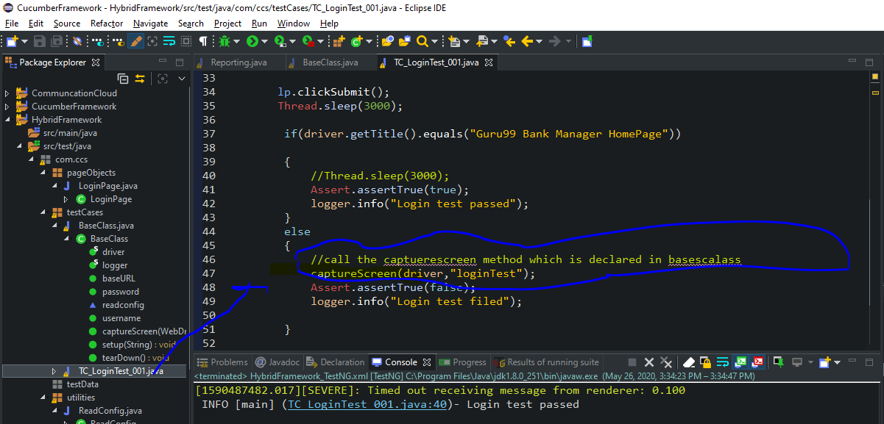

1. Creatre Data driven test cases

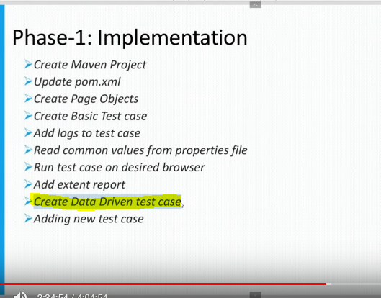

Following dependencies 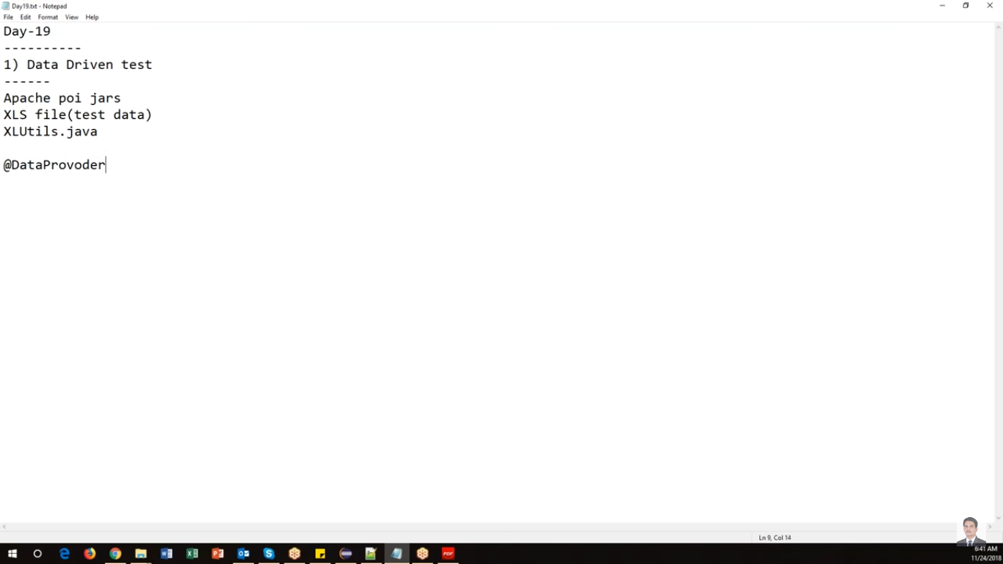

Following dependencies should be added in POM.XML

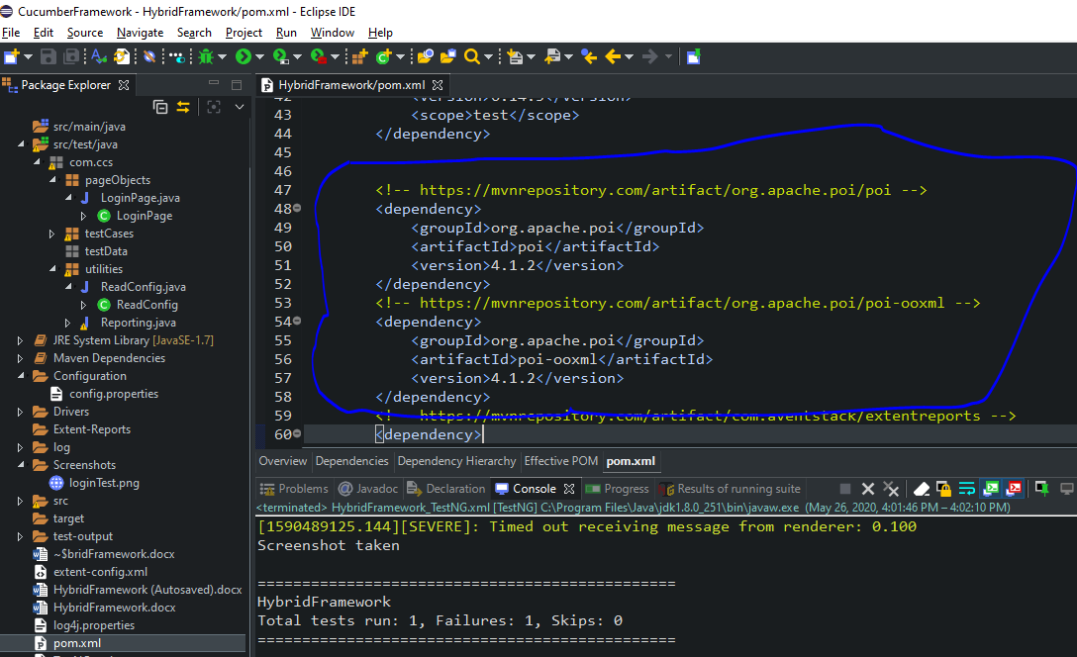

Create XLUtils calls under utilities package

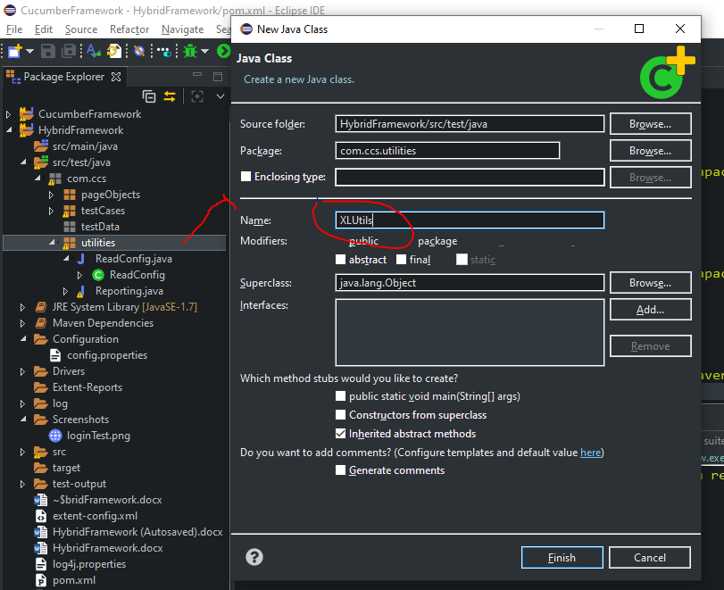

Create **loginData.xlsx** under **testData** package by selecting New->File

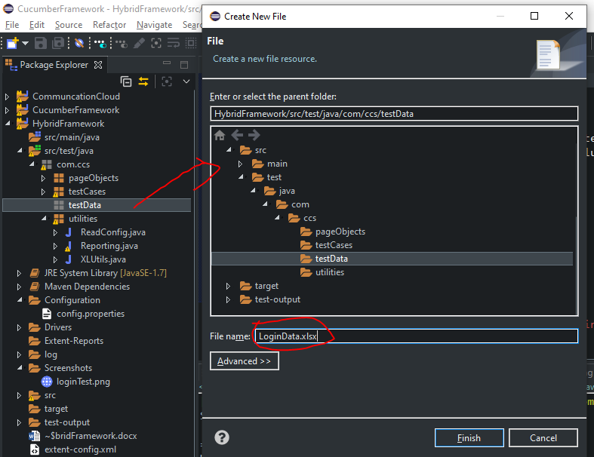

Create test case under testCase package

Select testCase package->New->Class and enter class name as “TC_LoginDDT_002”

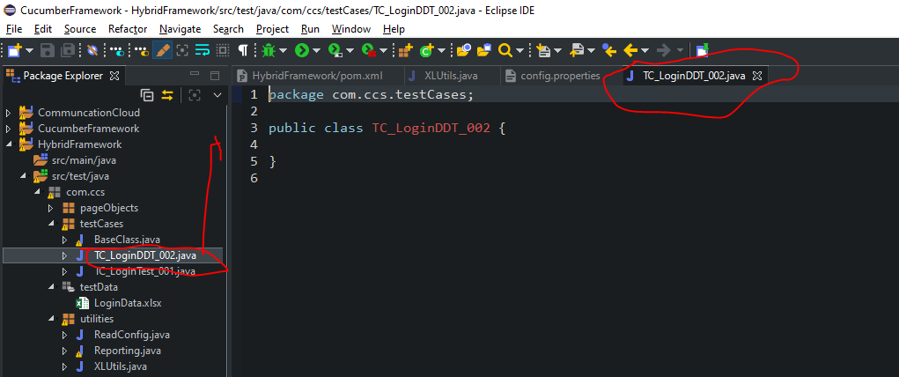

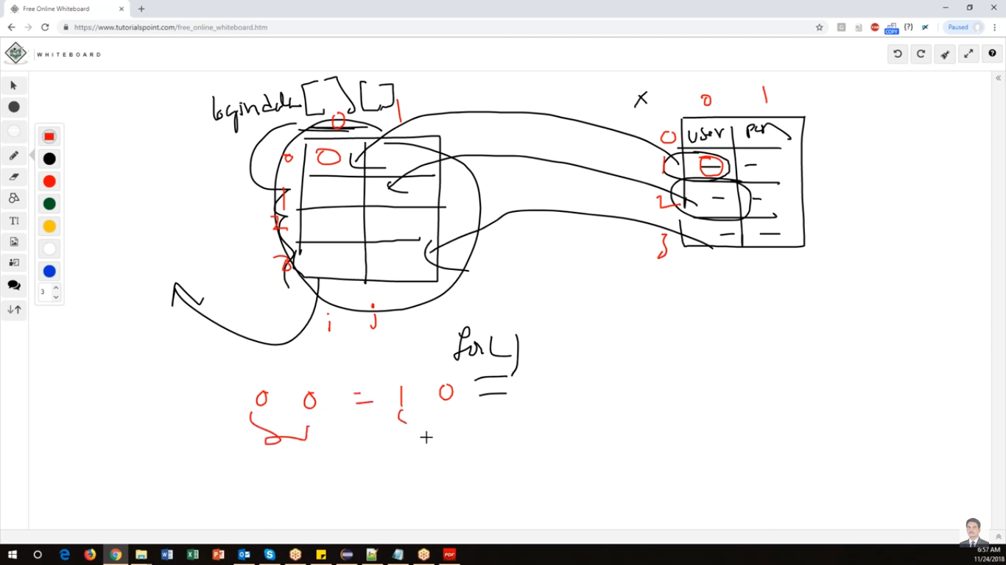

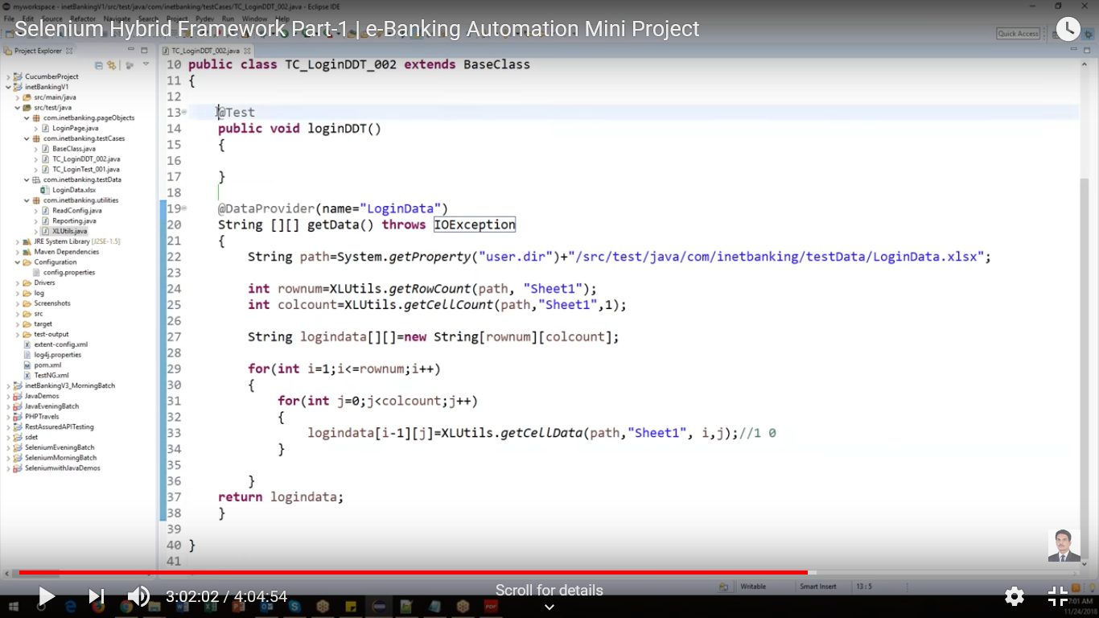

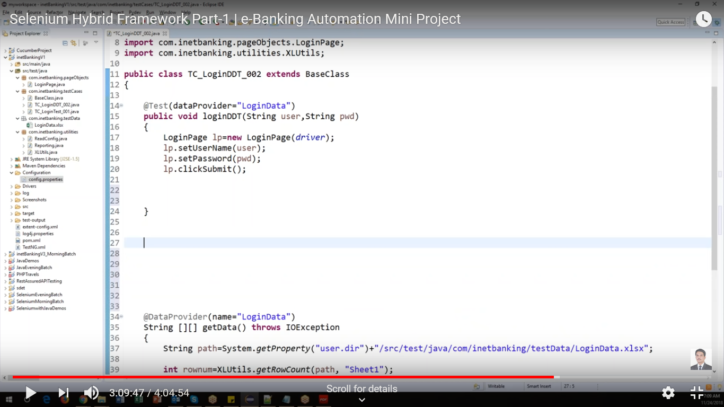

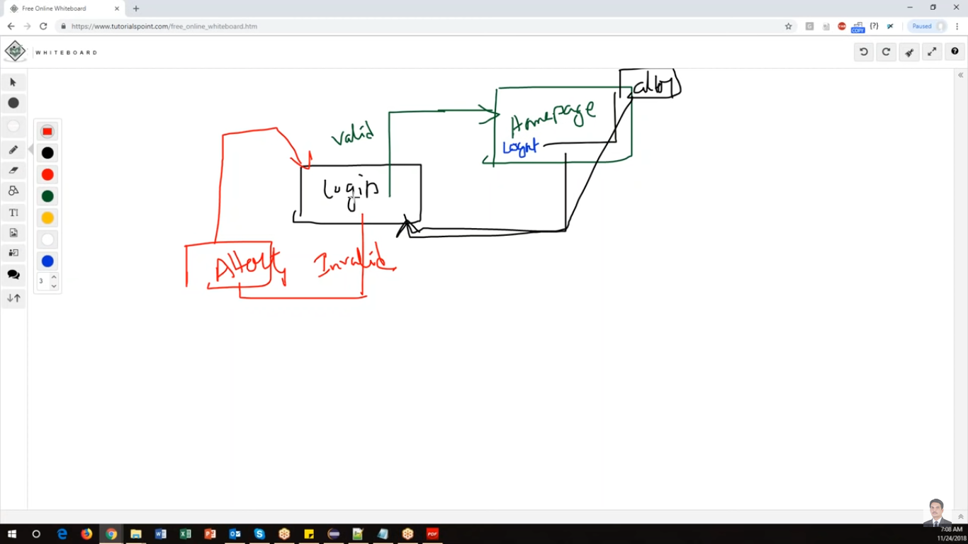

Framework is completed with this

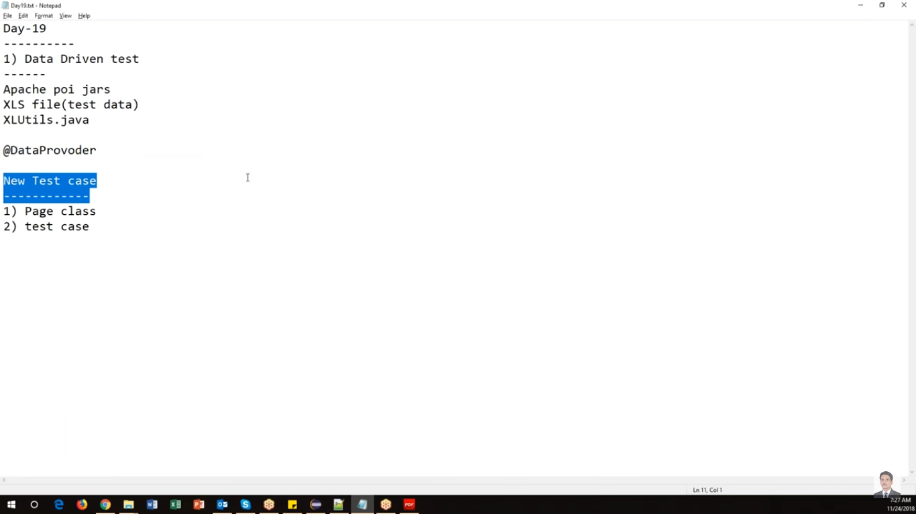

Create new customer in the paGE

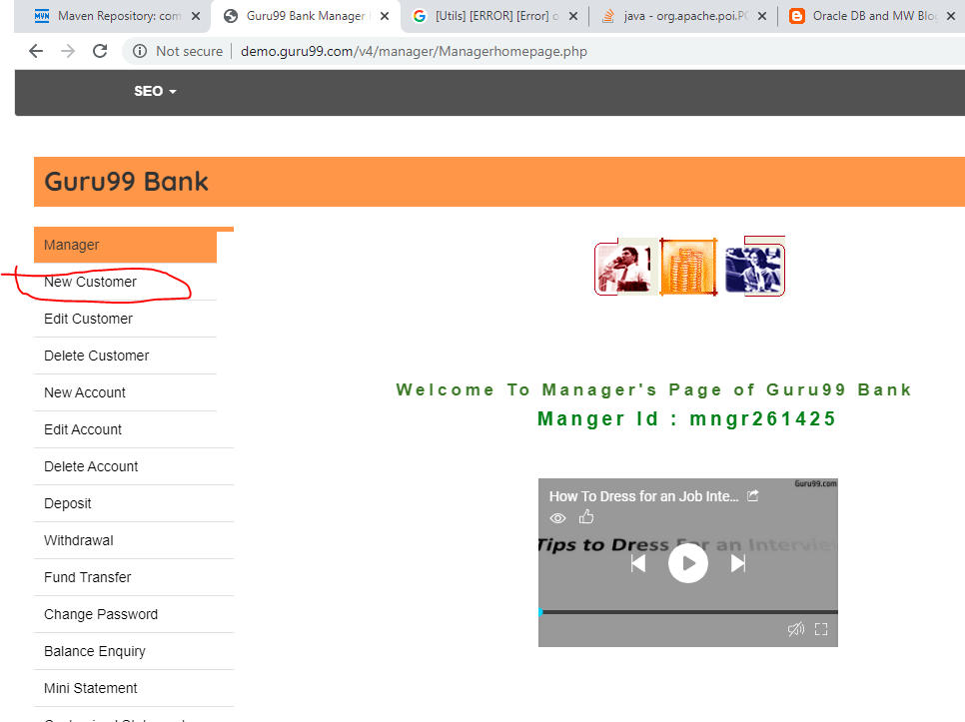

Create new page with **AddCustomerPage.java** under **pageObjects** package

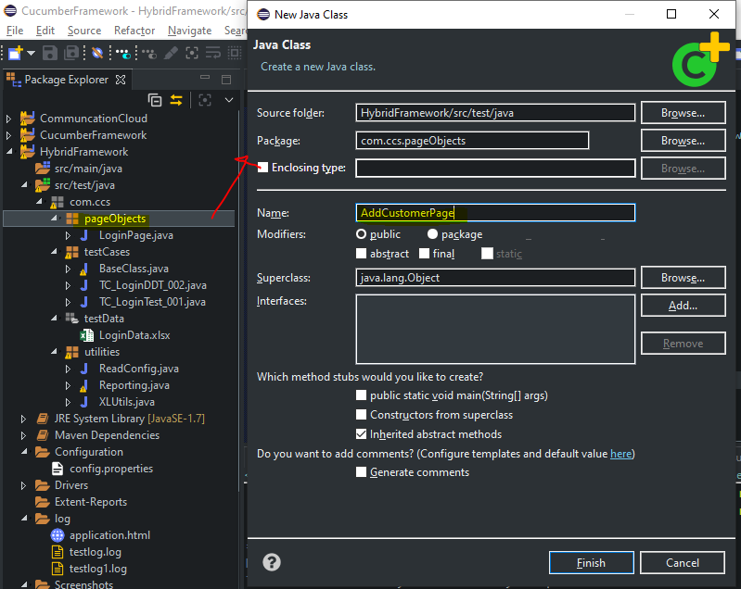

Create new test case with the name of “**TC_AddCustomerTest_003**” for the above customer page

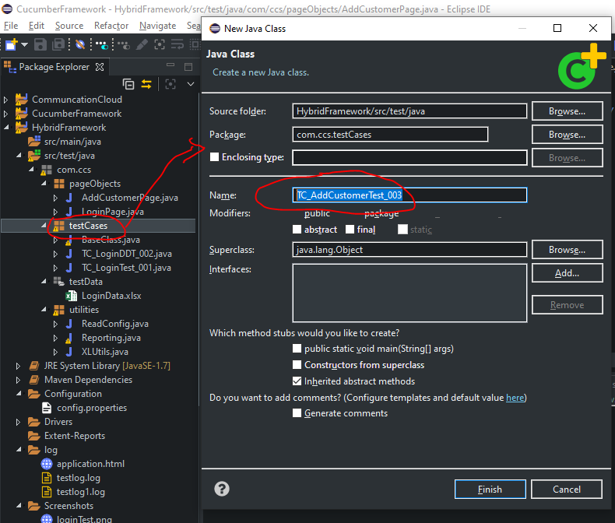

If you want to run all the test cases, add all the classes in **testing.xml** and run

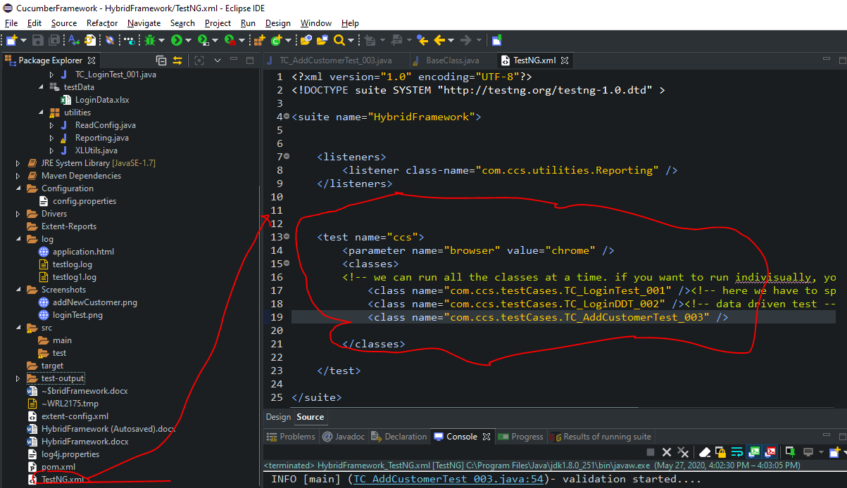

## Run Failed Test cases only

If some of the test cases are failed and you want to run only failed test cases

Step 1: expand test-ouptput folder under your project-

Step 2: select “testing-failed.xml

Step 3: righ click->Run As->TestNG suite

Result: it will run only failed test cases

## Assignment:

Framework designed

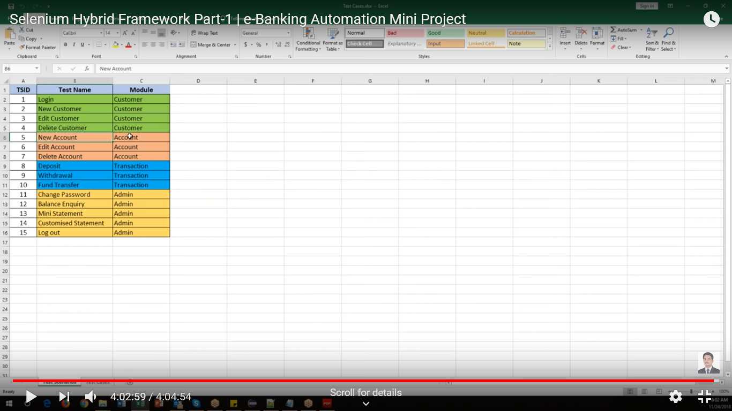

Other test casases can be tried

Selenium Hybrid Framework Part-2 | e-Banking Automation Mini Project

Link- <https://www.youtube.com/watch?v=7cFwCXY2DSg>

Continues Integration

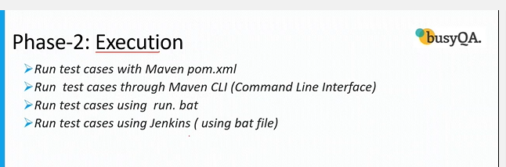

2.1 Run tests using POM.XML(within Eclipse)

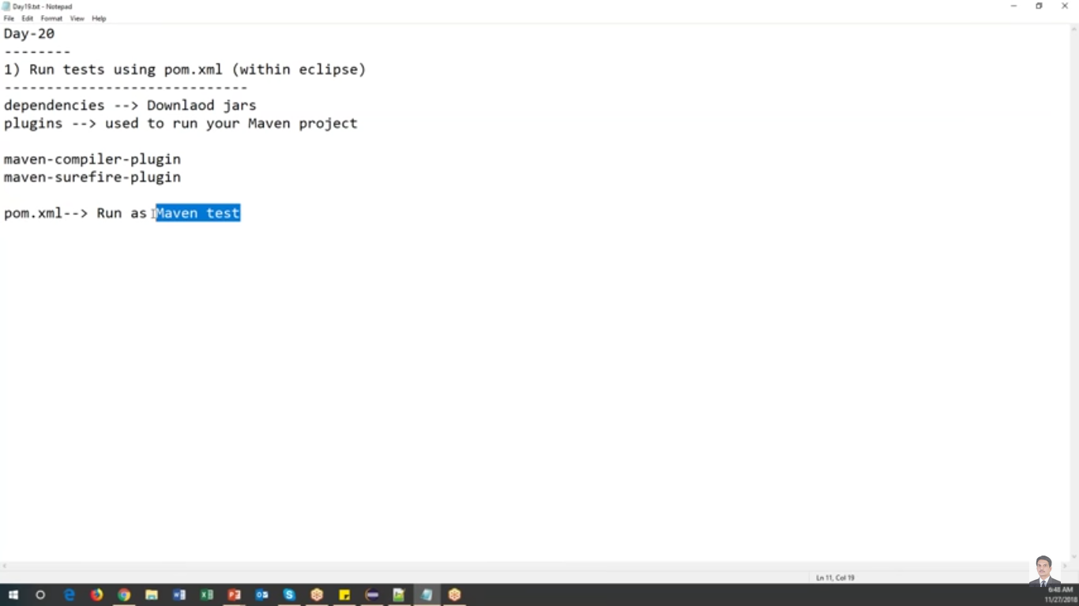

Usages of pom. XML

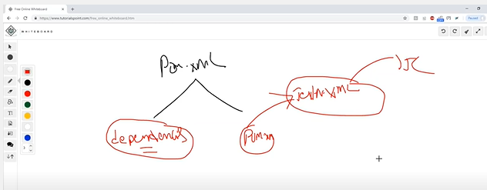

Run TestNG through POM.XML

Plug-ins in POM.XML

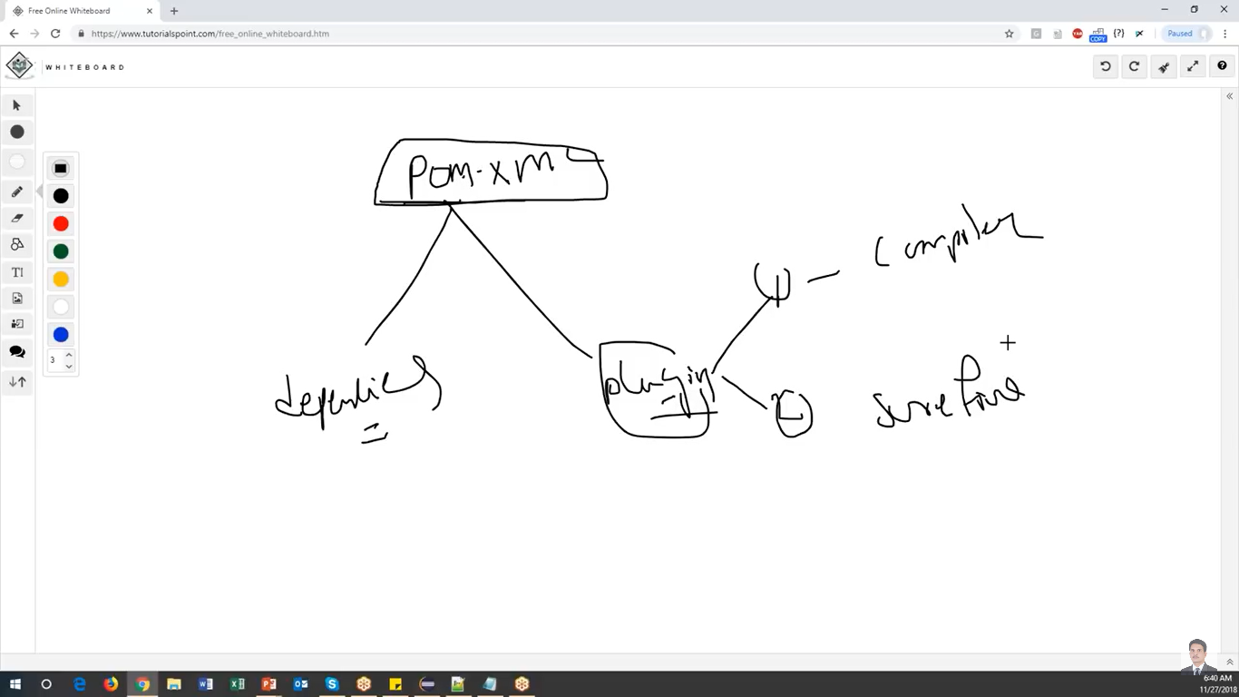

Add below plugoins in POM.xml

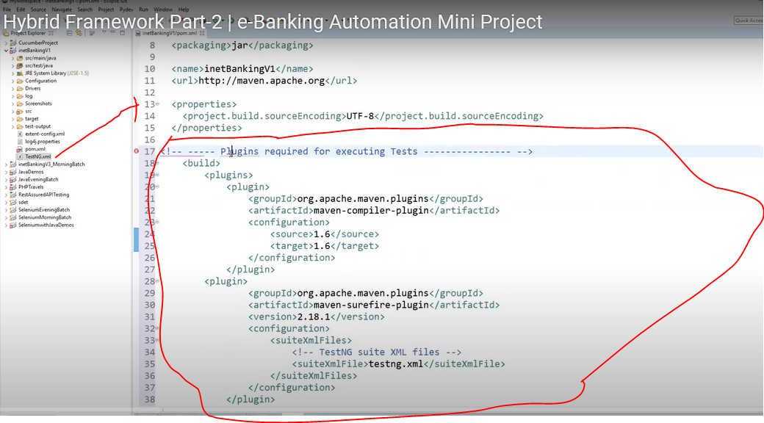

Save, update project

Select POM.XMl->Run As->Maven Test

2.2 Run test cases through Maven CLI

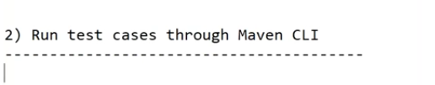

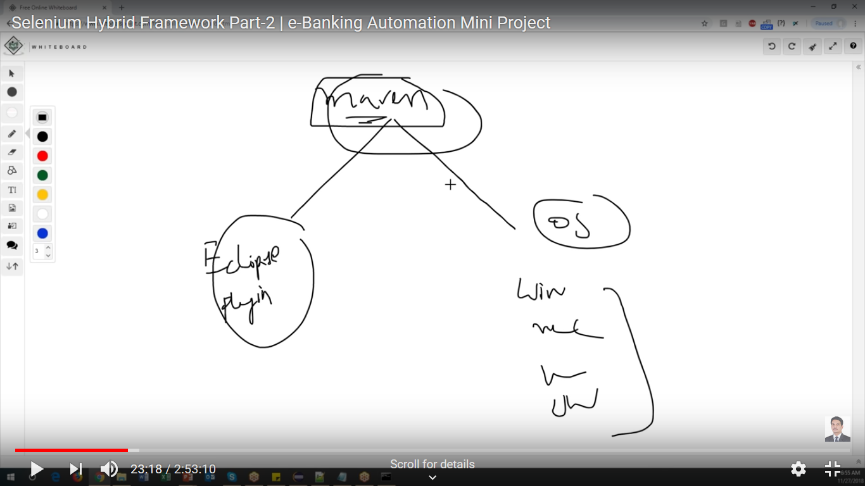

Download maven for windows10

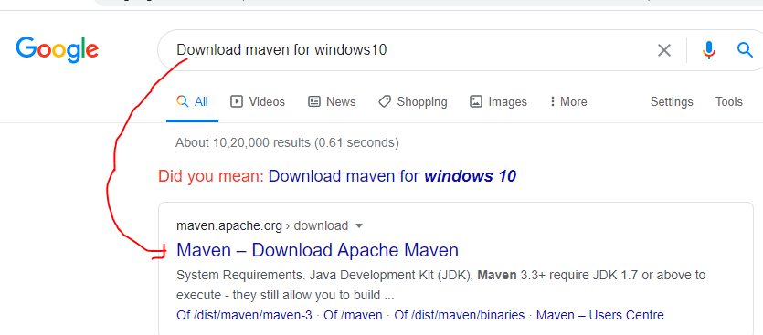

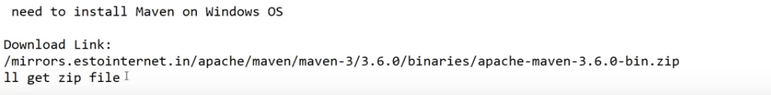

Unzip the file

Set path variable

D:\Selenium\apache-maven-3.6.3\bin

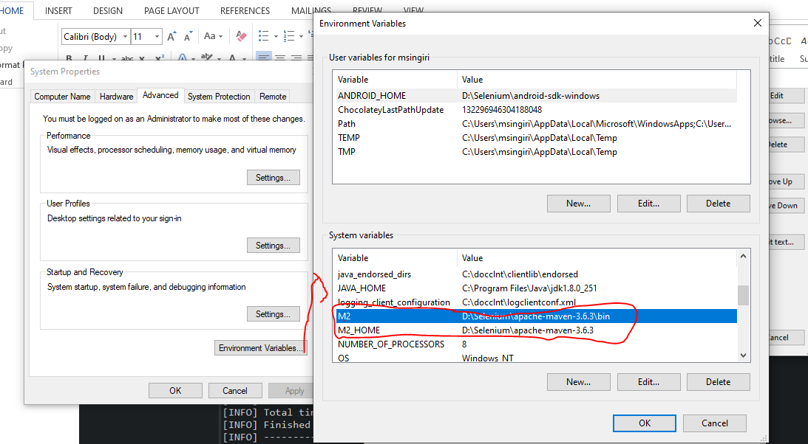

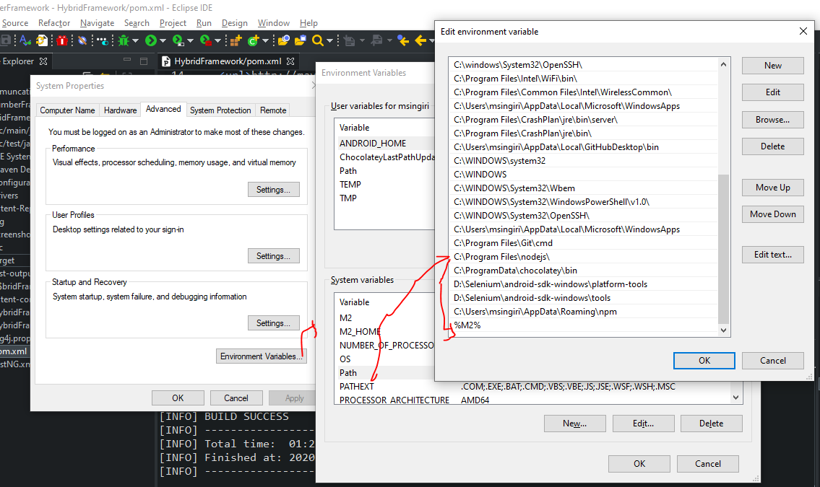

Check the MVN version in command prompt

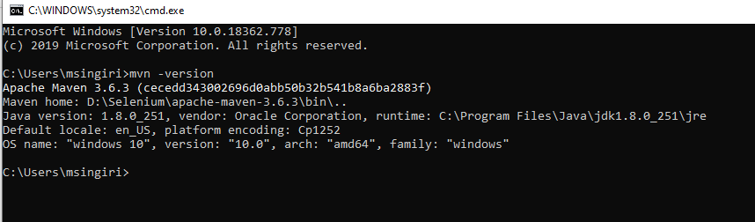

Close your Eclipse

Project Location: D:\Selenium\CucumberFramework\HybridFramework

Command Prompt:

cd D:\Selenium\CucumberFramework\HybridFramework

mvn clean install

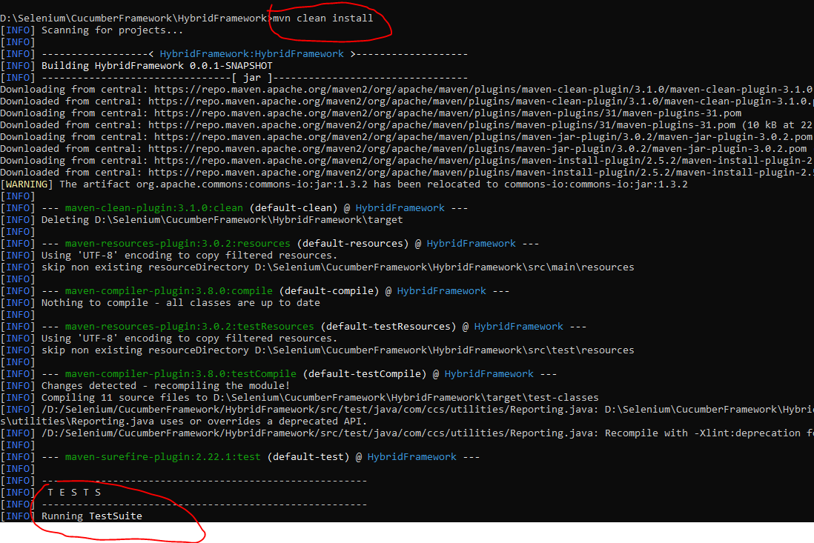

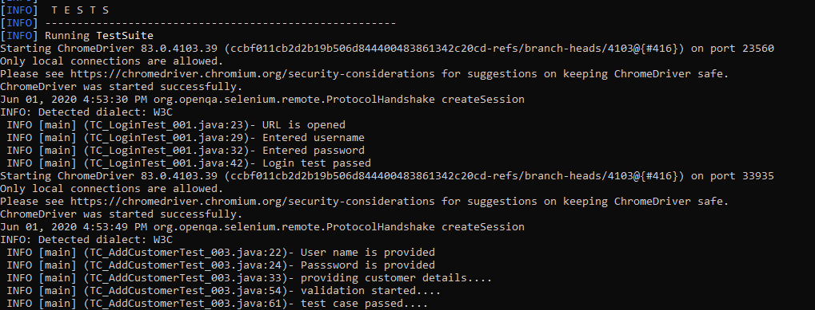

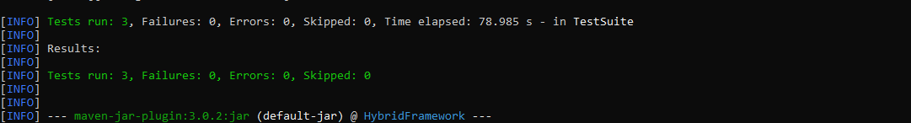

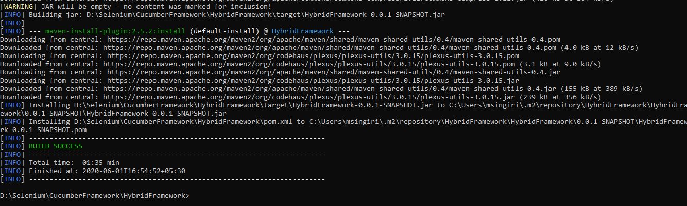

2.3 Run test cases through run.bat

Create bat file in project location:

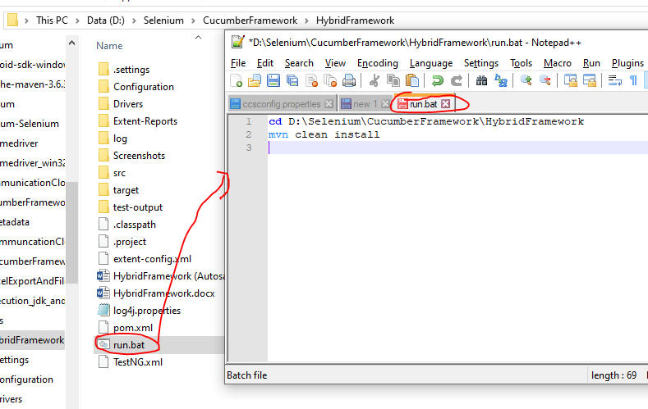

1. Run tests using Jenkins
   1. Continuous integration Process

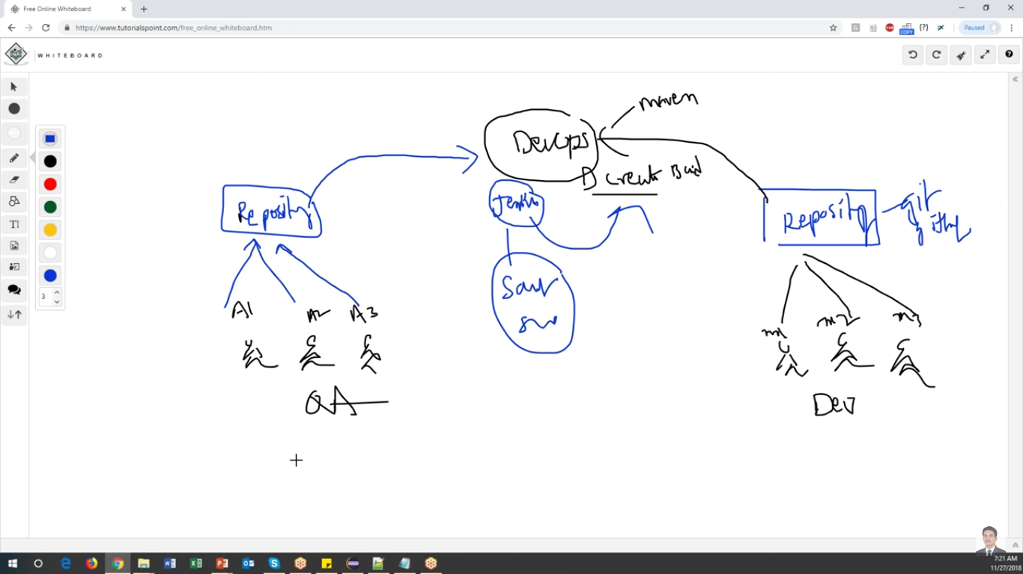

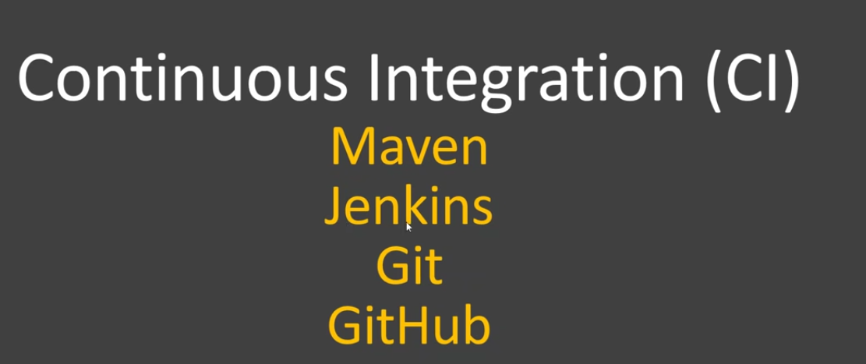

Jenkins installation and Configuration

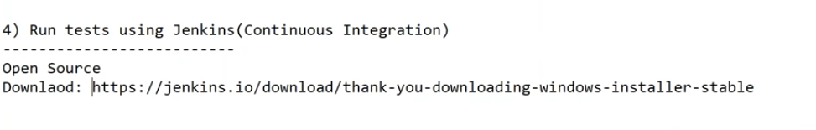

Double click on msi file

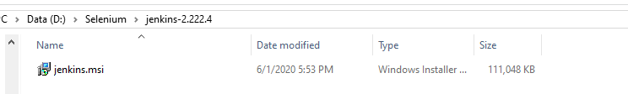

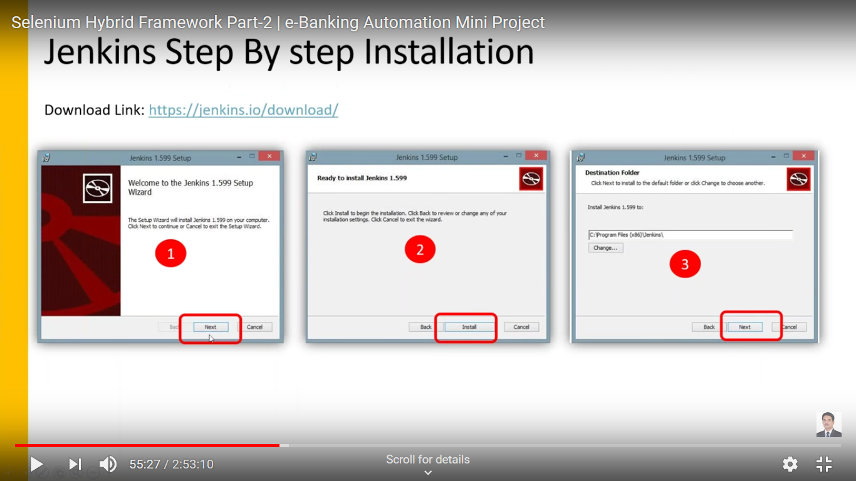

Jenkins Configurations:

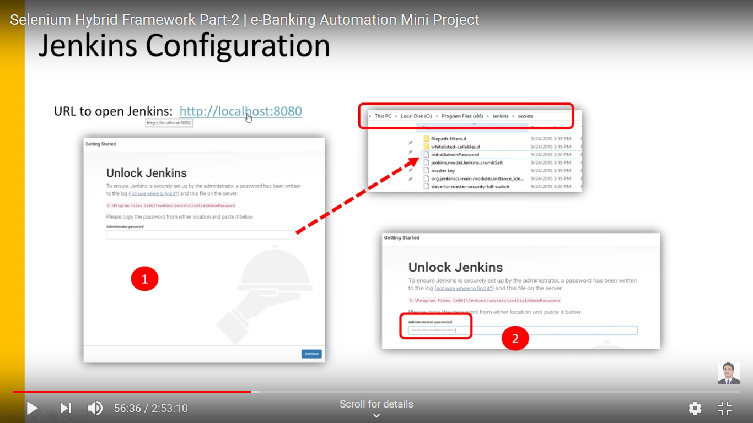

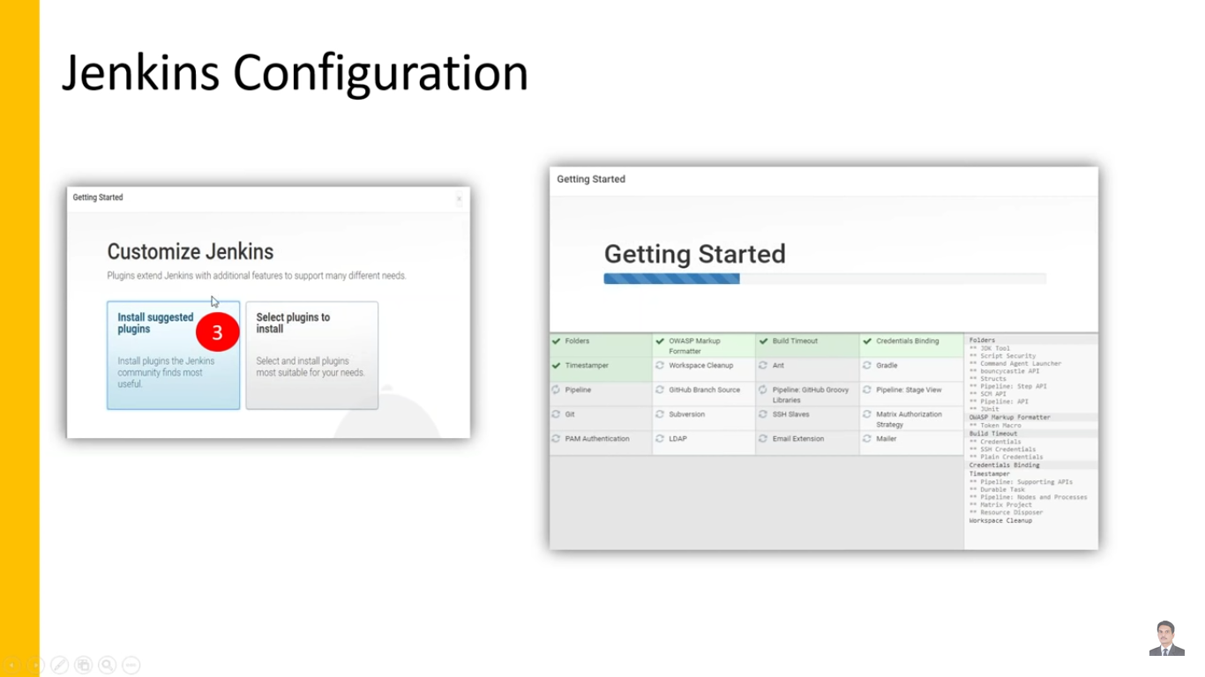

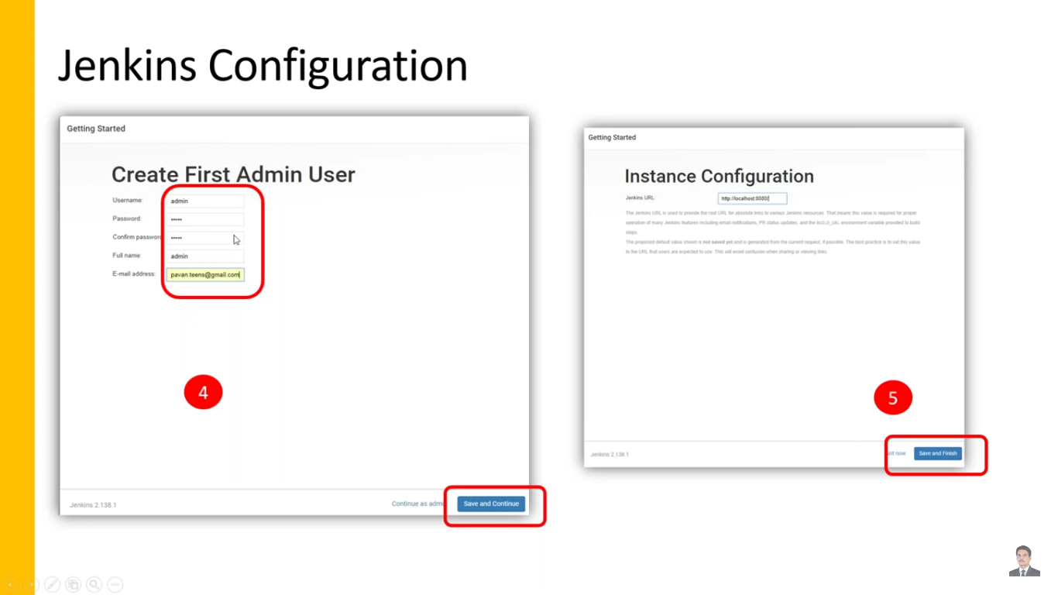

Launch Jenkins

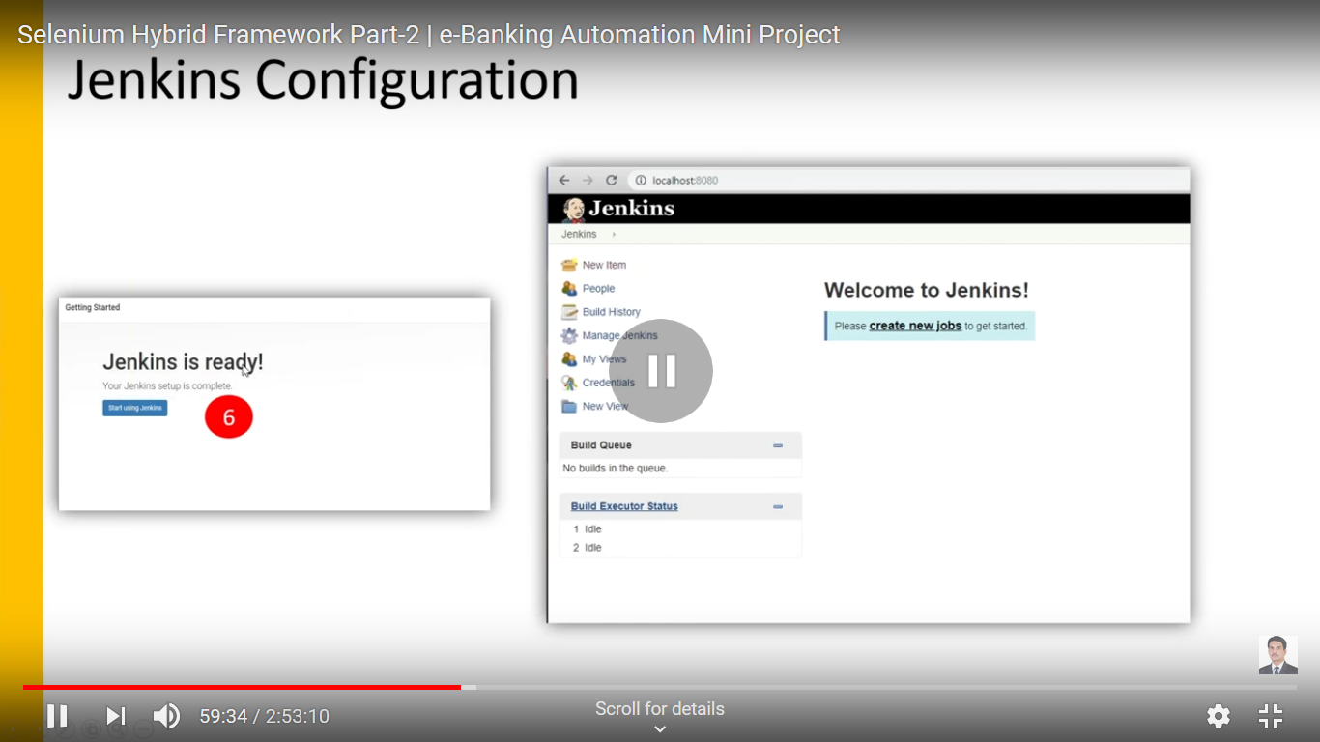

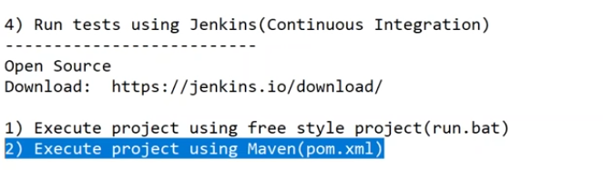

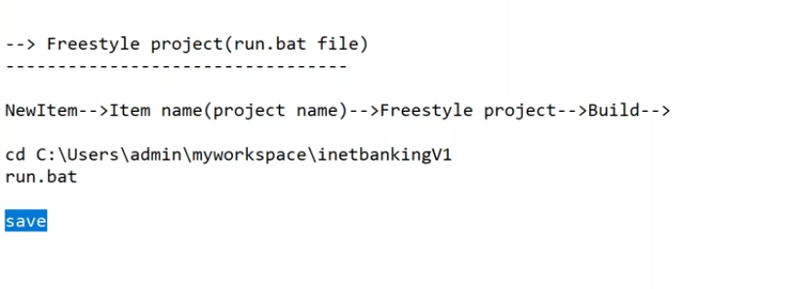

4.1 Execute Project using free style project(run.bat)

Login to Jenkins, New item

Enter project name and select freestyle

Enter Project description

Add build step as “Execute windows batch command”

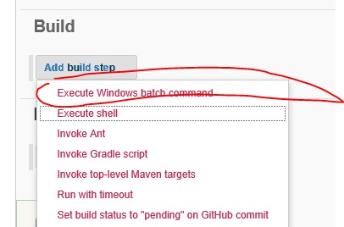

Add project location and batch file name

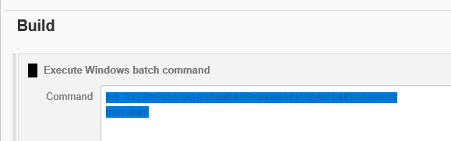

Run Project

Click on the project and Build now

Once you run the project Test will run in background. So you can’t see browser launch and execute frontend.

4.2 Execute project using Maven(pom.xml)

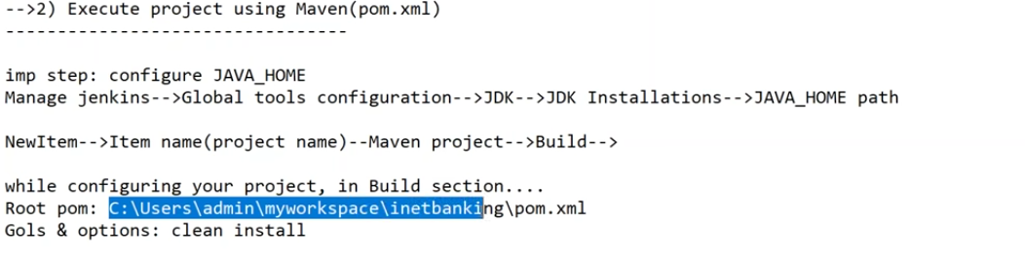

* Install Maven plug-in in jenkins

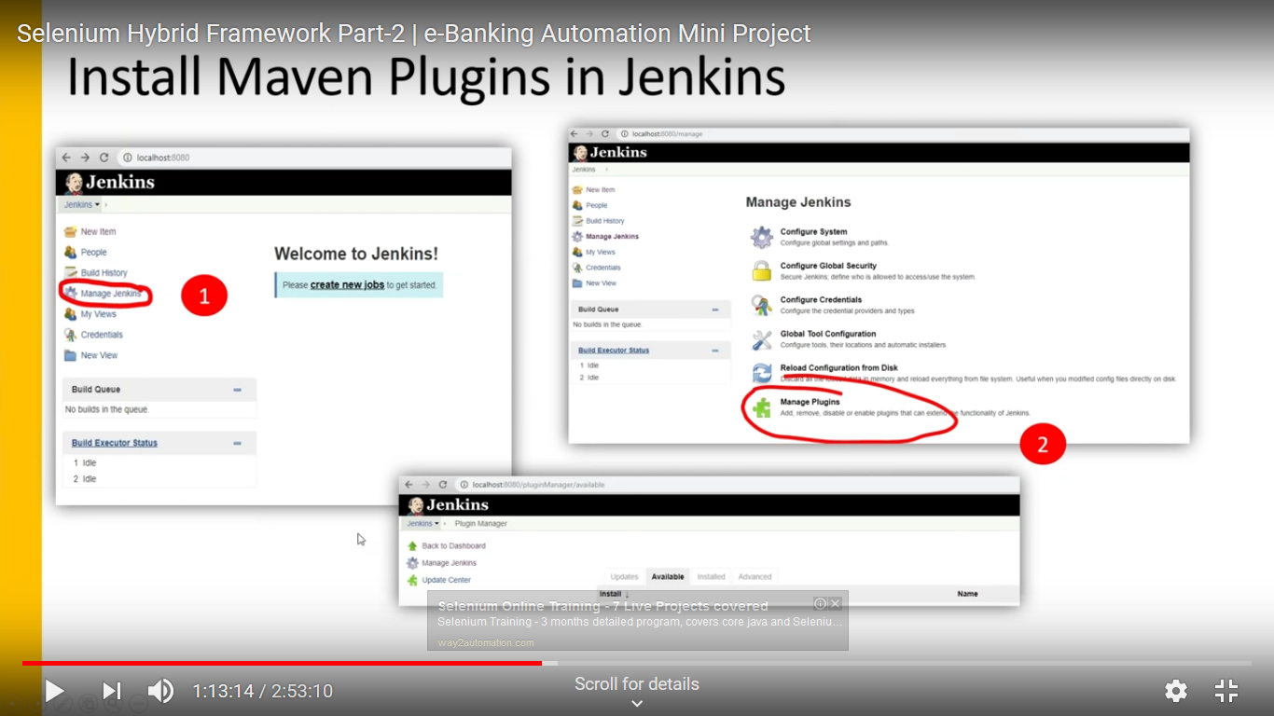

Select below options

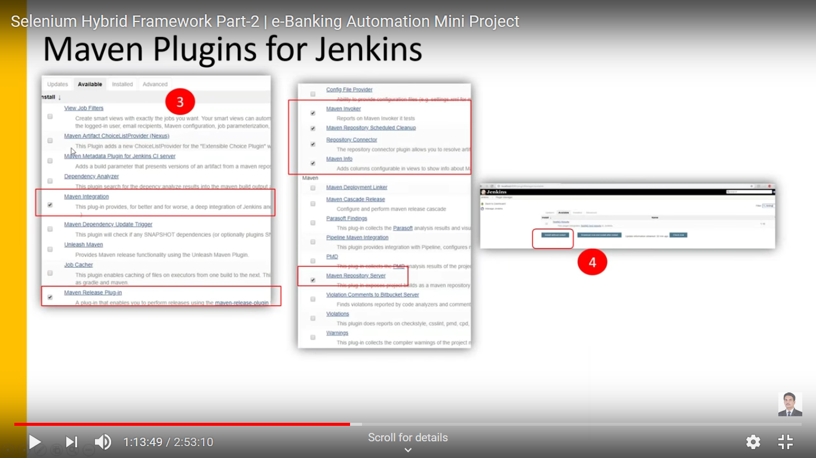

Re login to the jenkins with admin credentials

Add jdk path

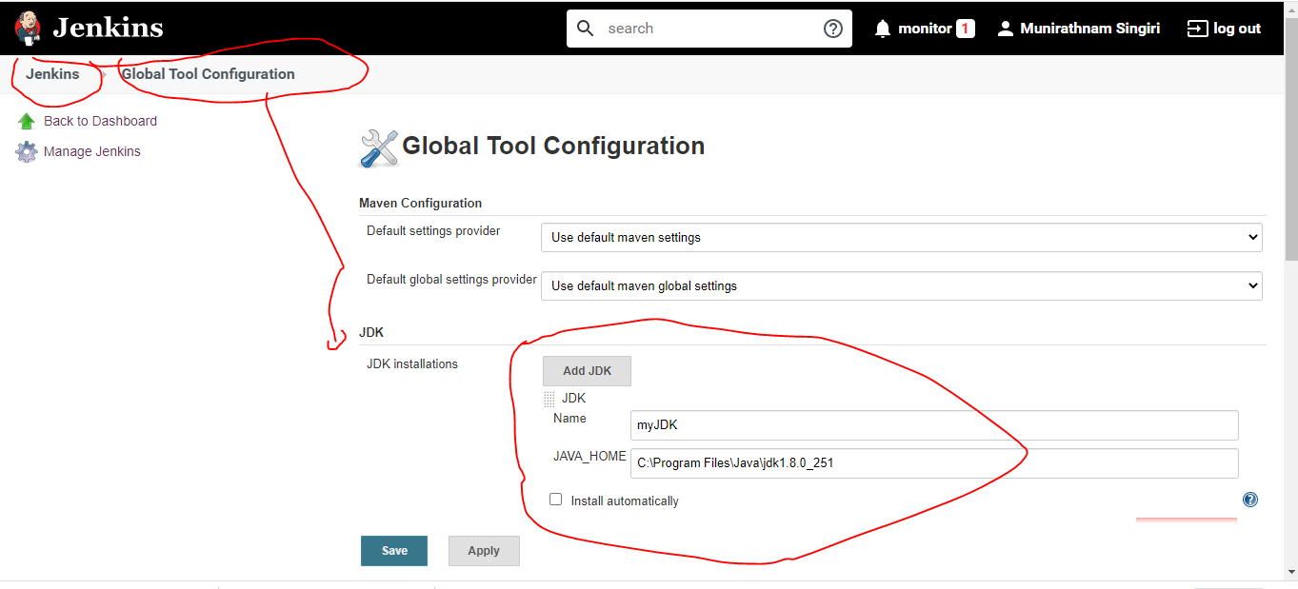

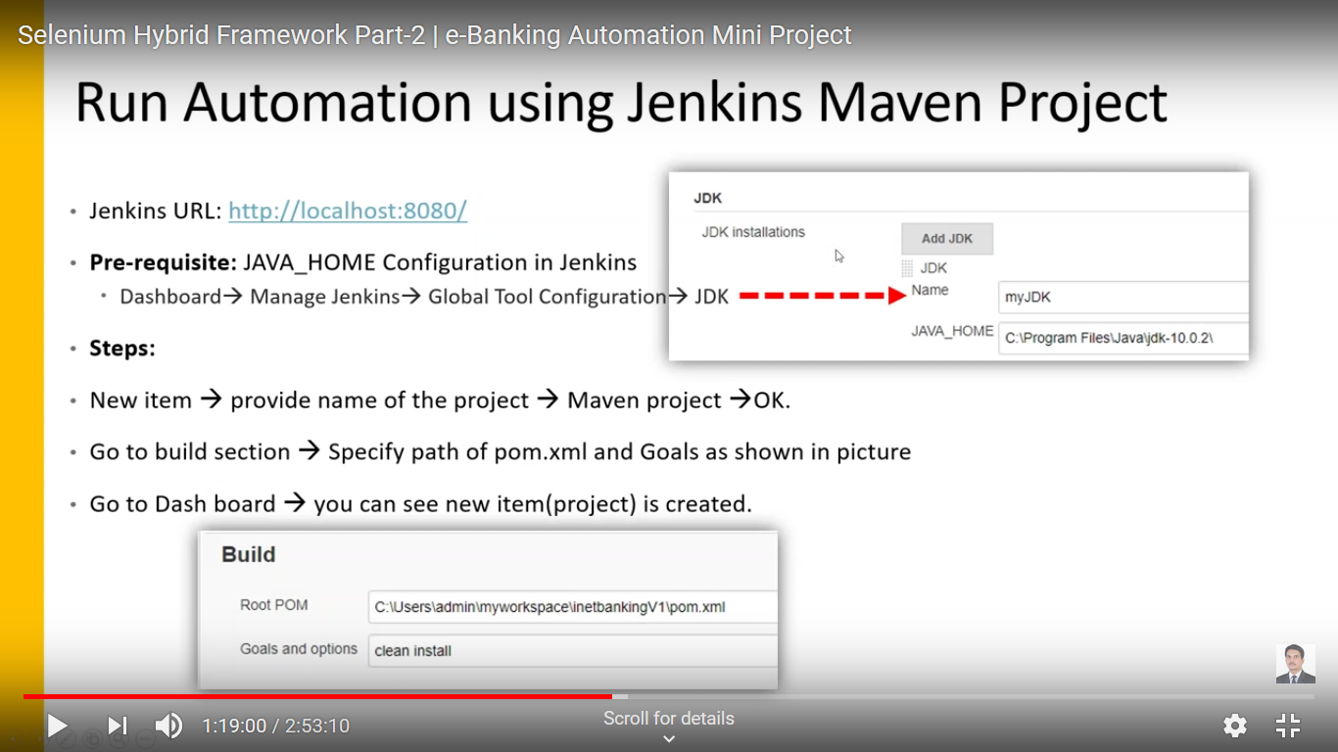

Jenkinn-New Item- give the project name

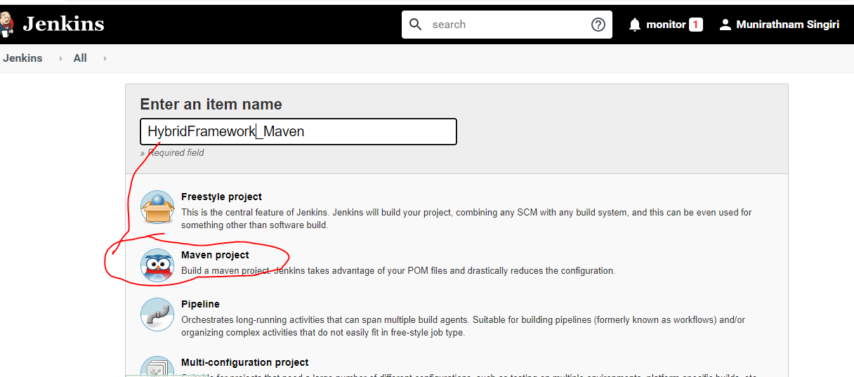

Update the project path and Maven command in Build section

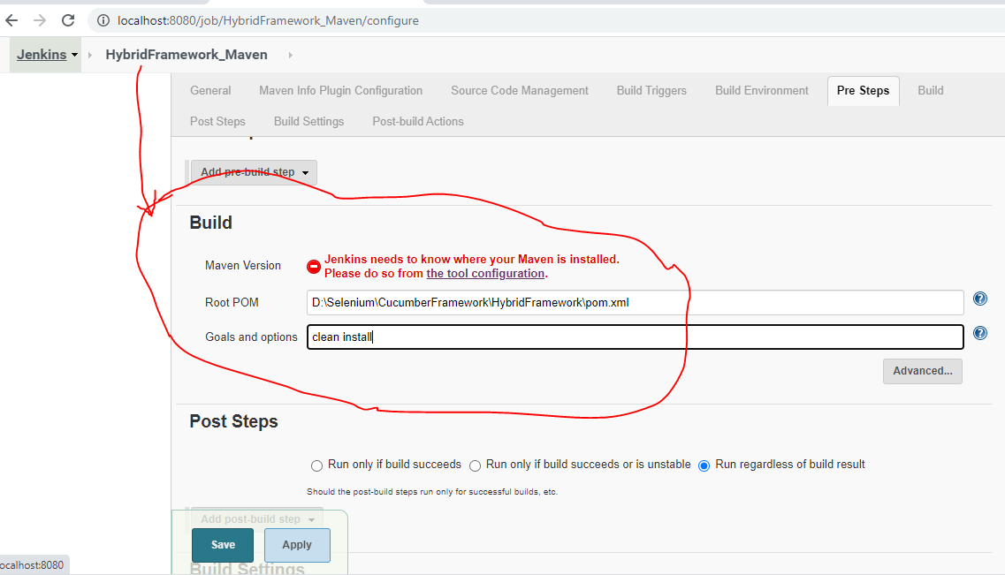

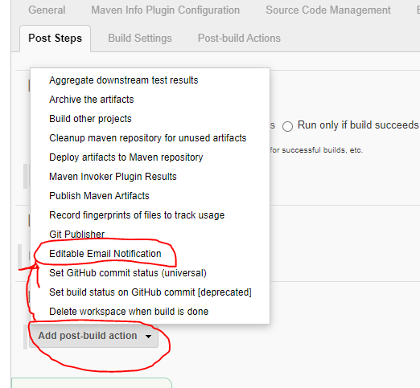

Leave the defaults and click Apply and Save

Go to the Dashboard and click on Project

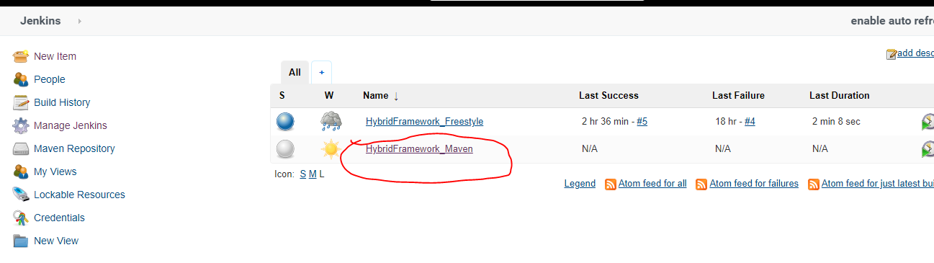

Click on Buld now to run the project

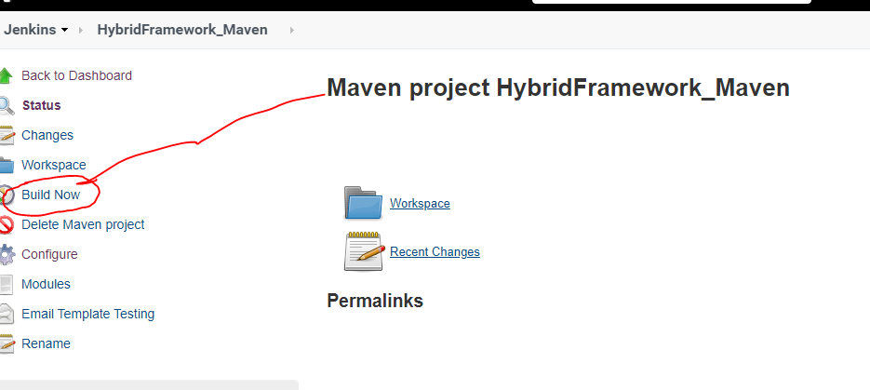

Check the result in Console output

Different ways to run project:

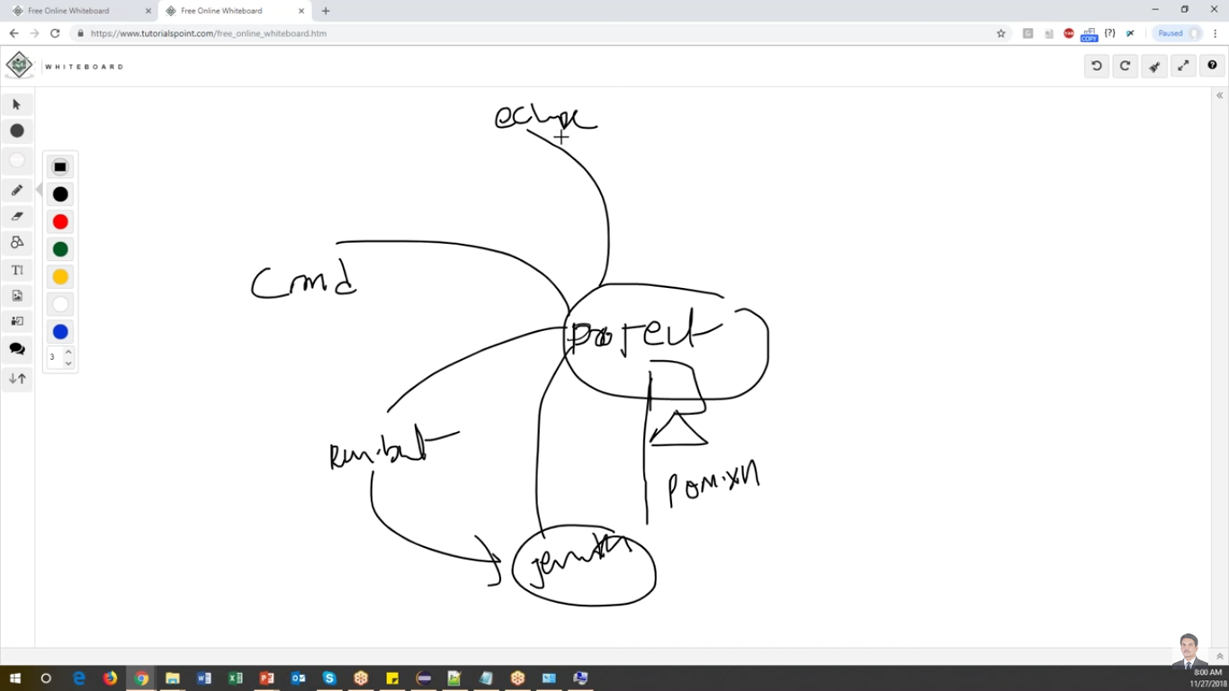

Real time project

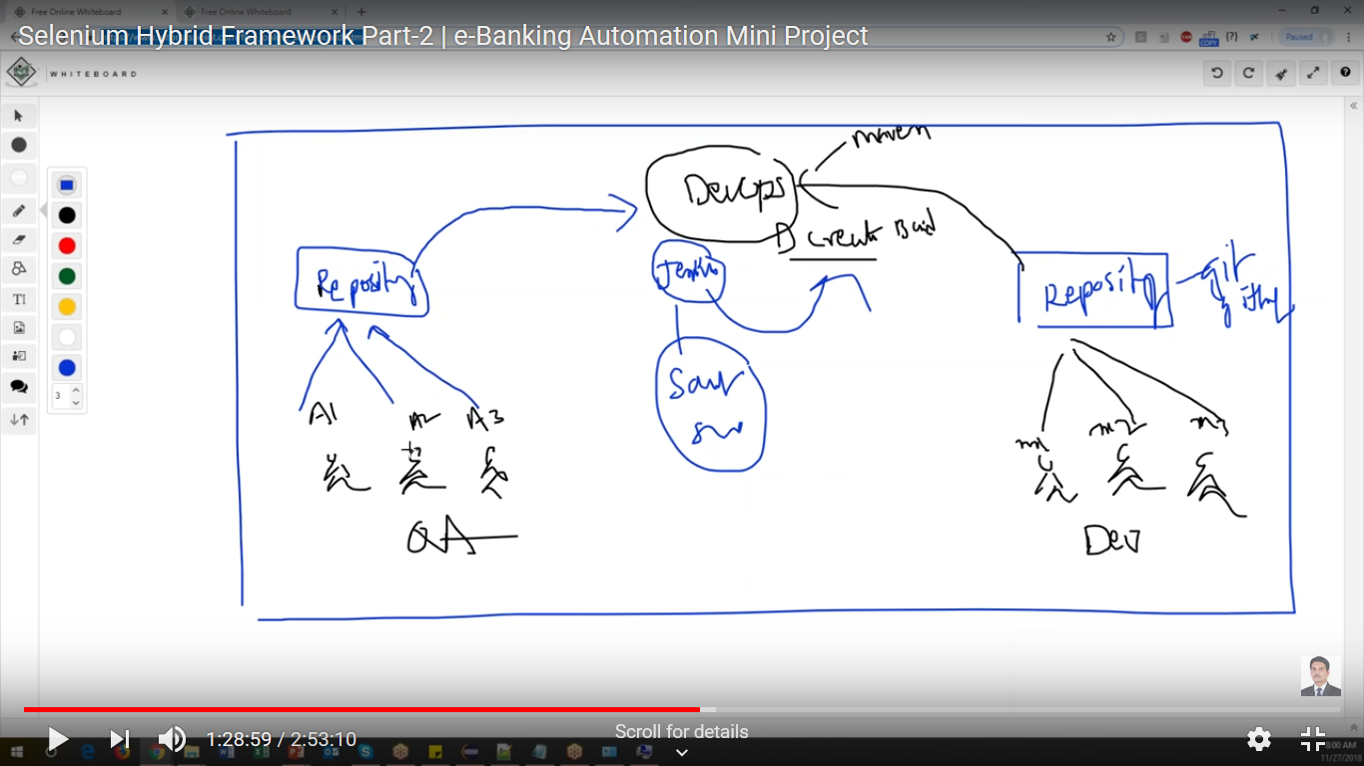

How to work with Git and GitHub

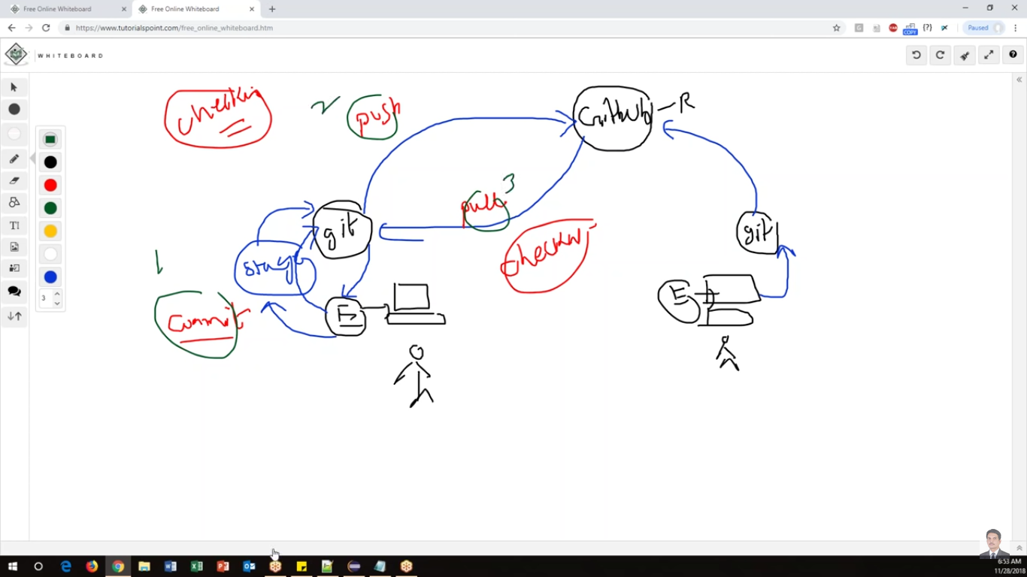

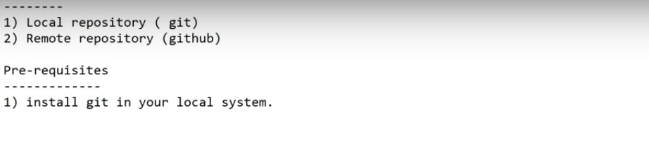

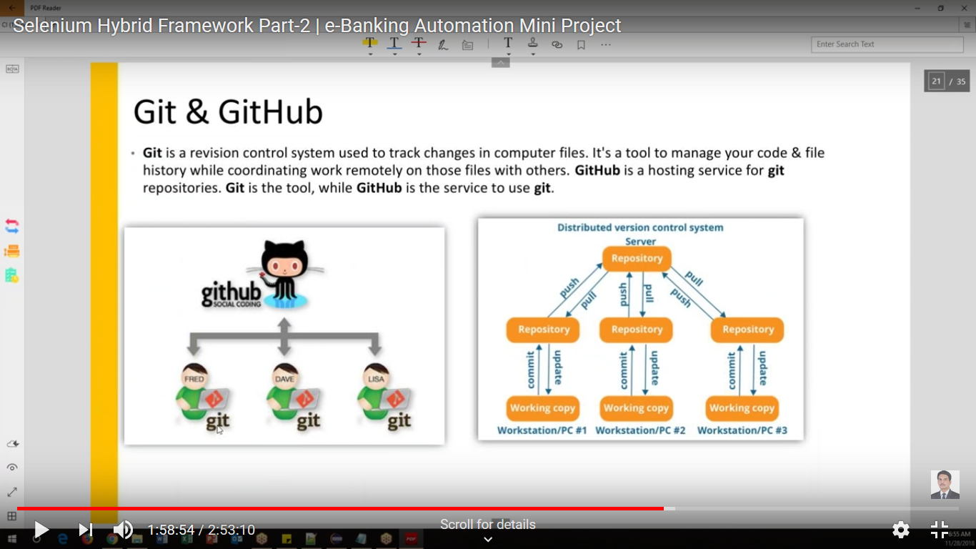

5.1 Local repository ( git )

* Install GIT

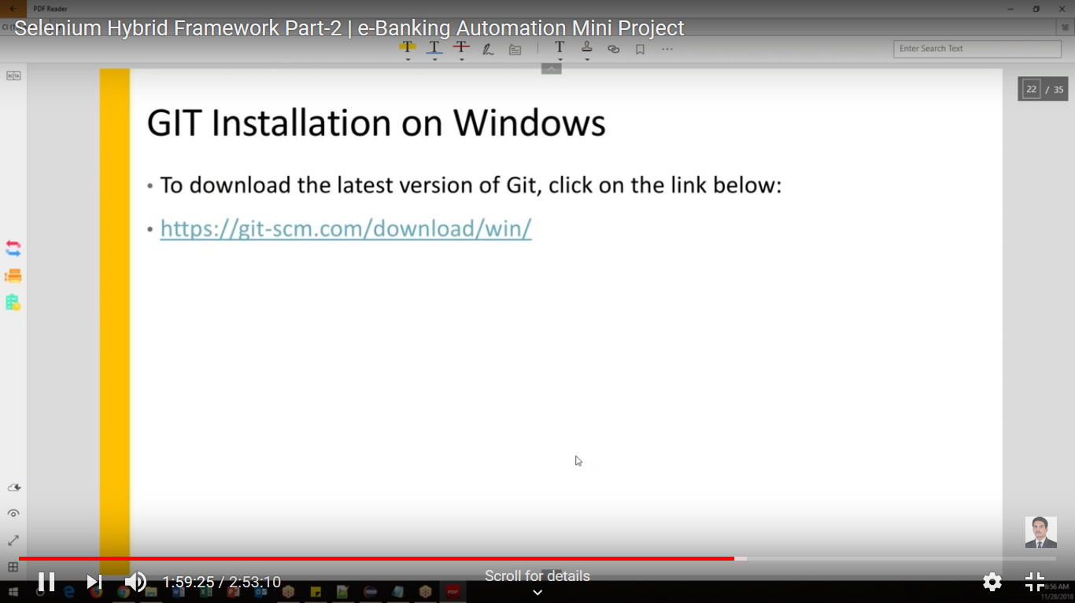

Url: <https://git-scm.com/download/win>

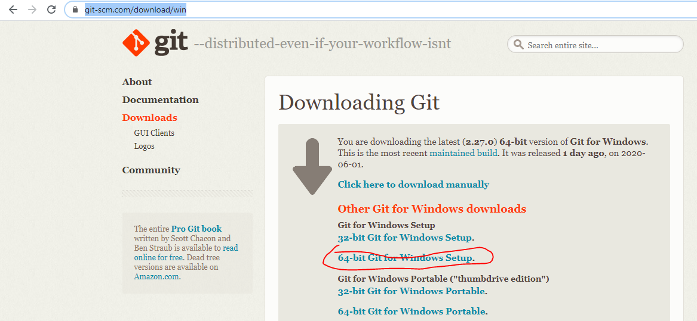

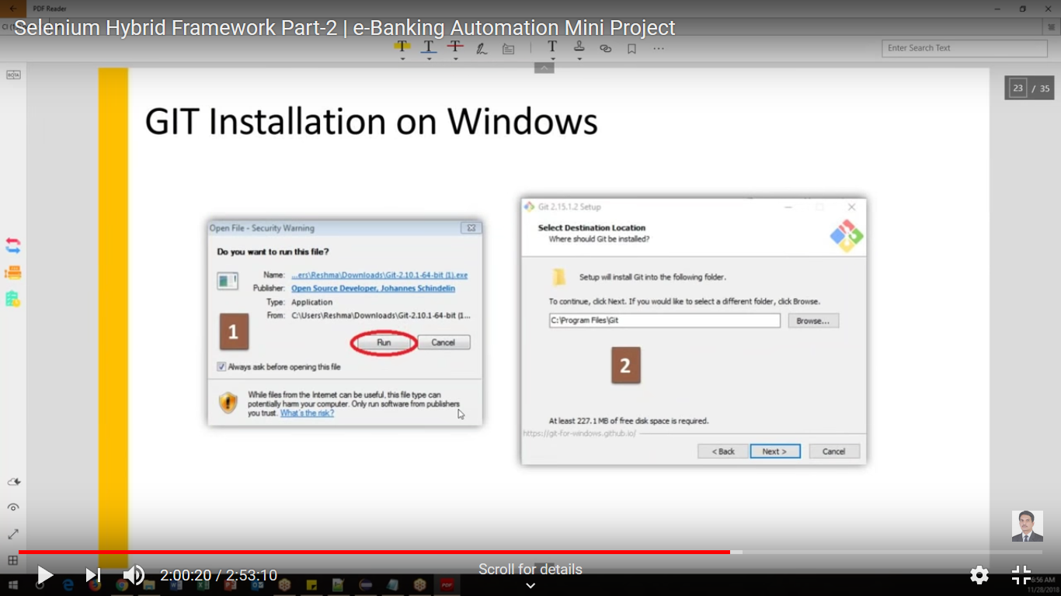

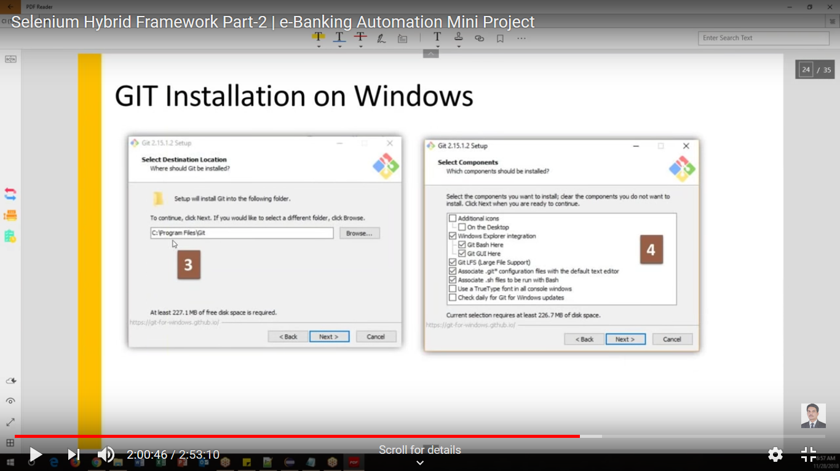

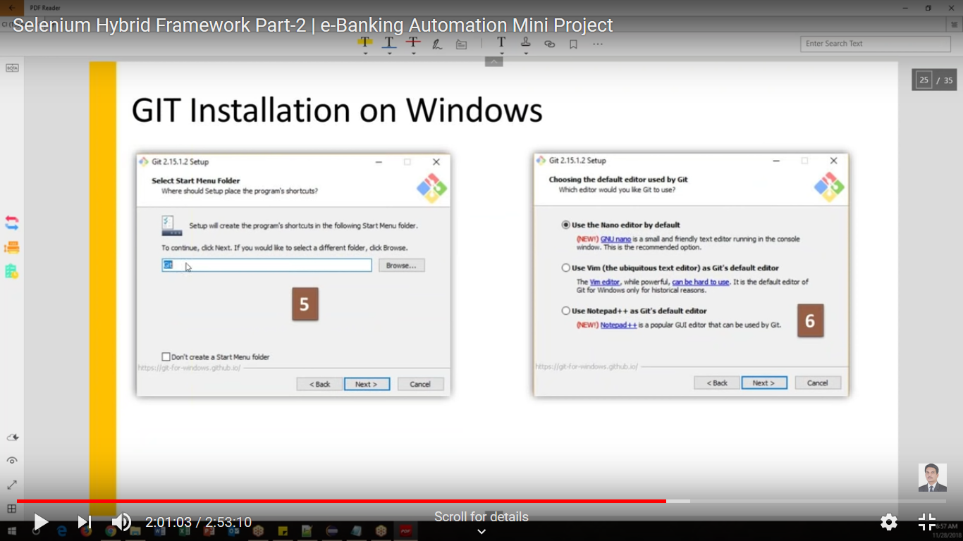

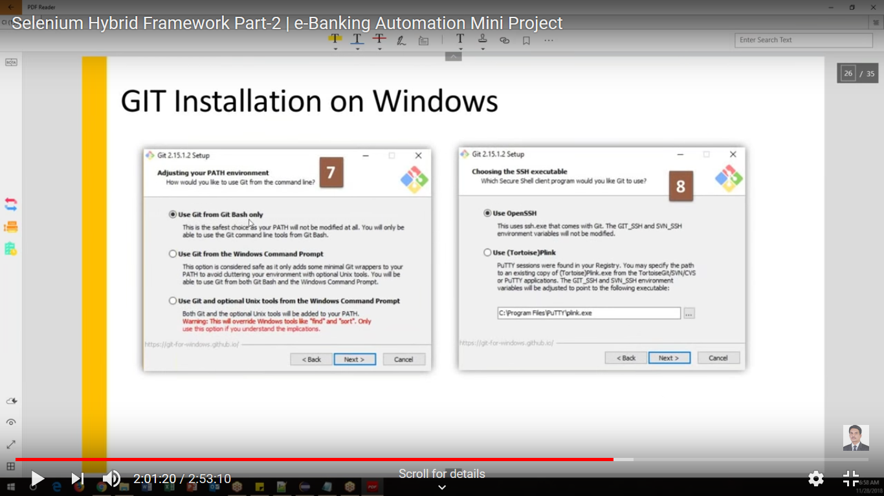

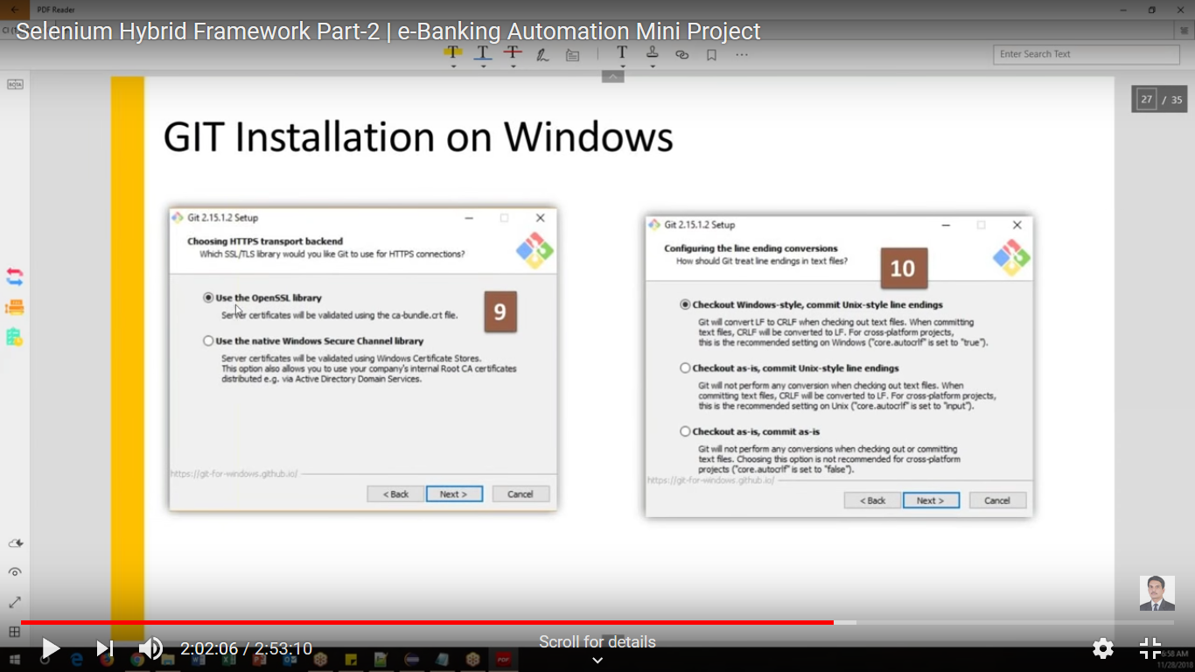

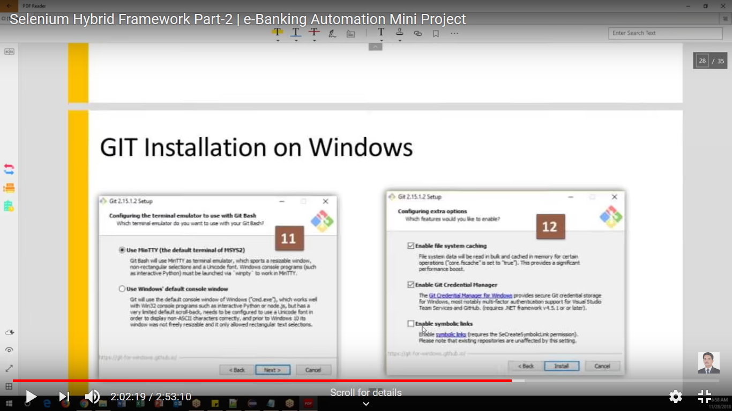

Click install

Navigate windows explore in any of the folder -> Right click and verify that GIT options are coming or not

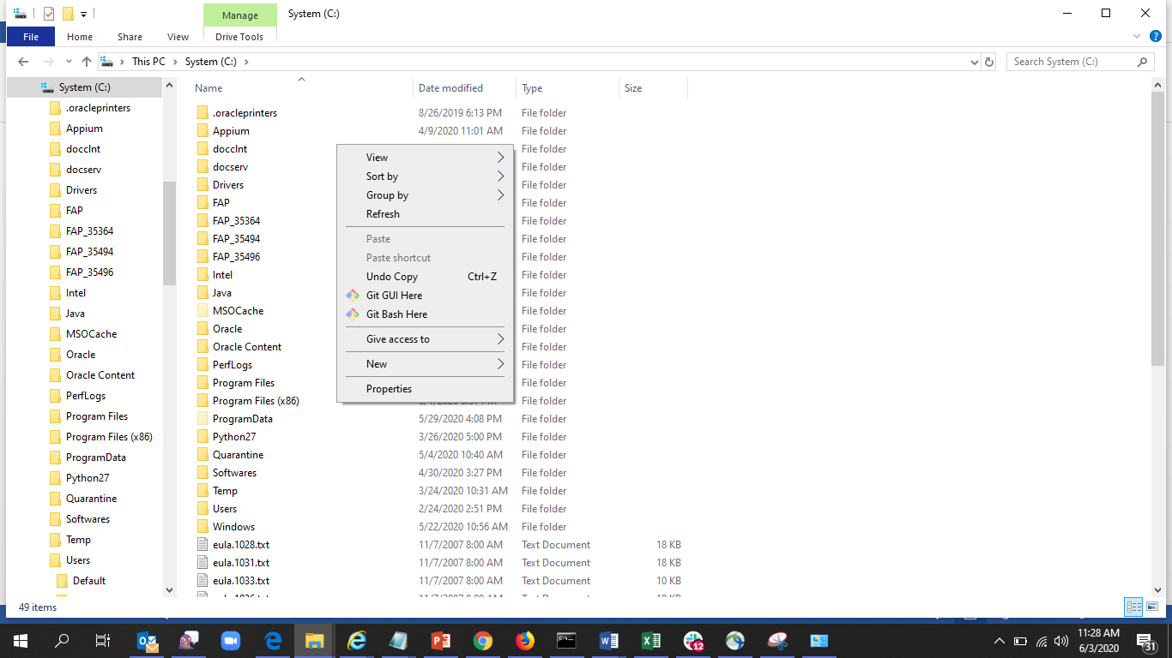

Workflow

Login to 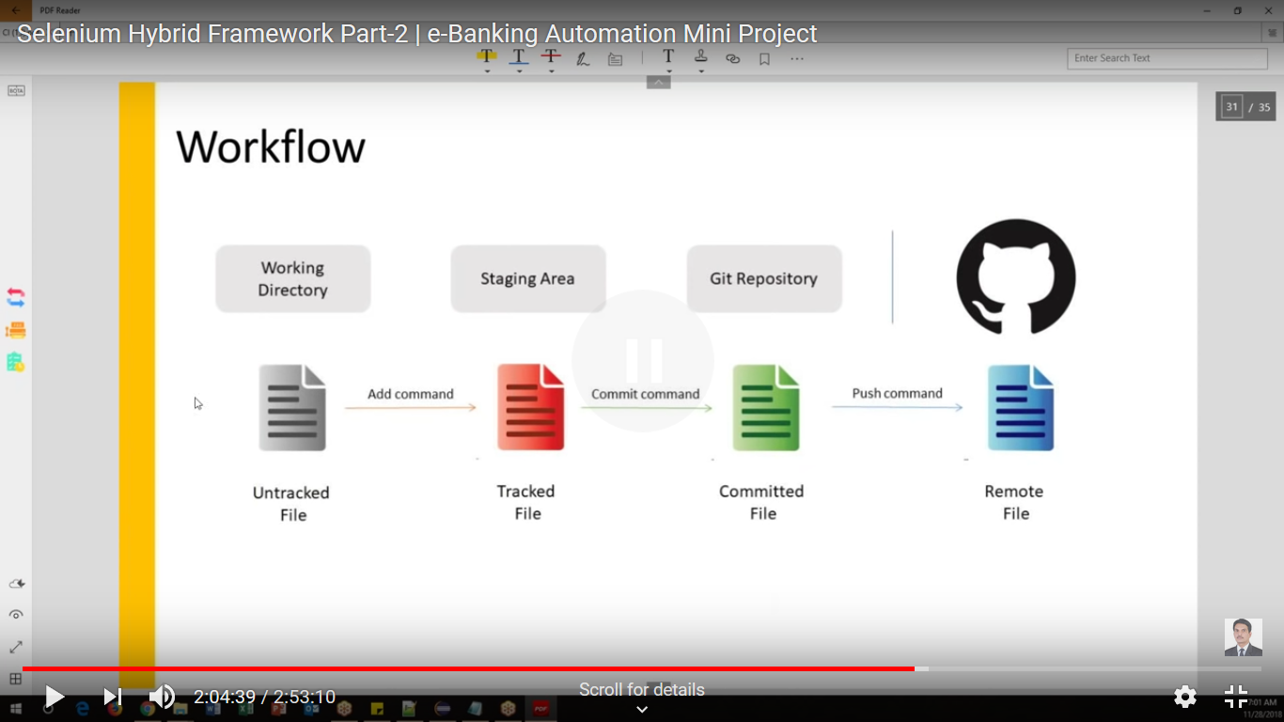

5.2 Remote repository(Git Hub)

Login to the Github- <https://github.com/>

Create new repository

Give the project name which is same as what you created in Eclippse

Create repository

You will get url like –

<https://github.com/mreddy25/HybridFramework.git>

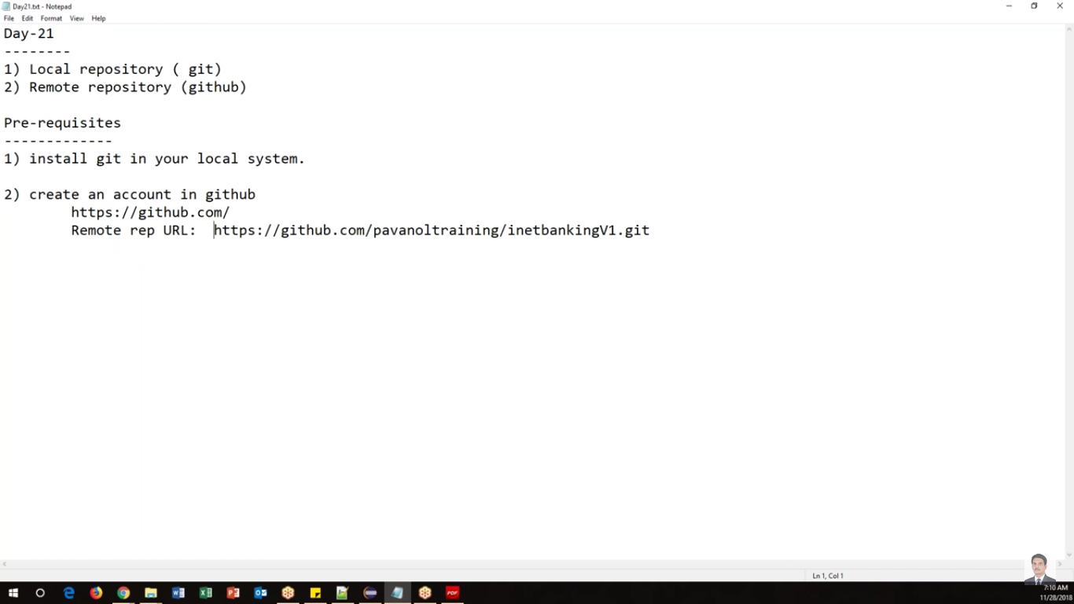

Open Eclipse and Update the project by selecting the project->Maven->Update Project

# Create local repository

Go to project folder and create local repository

Right click, click refresh

Right click, click “Git Bash Here”

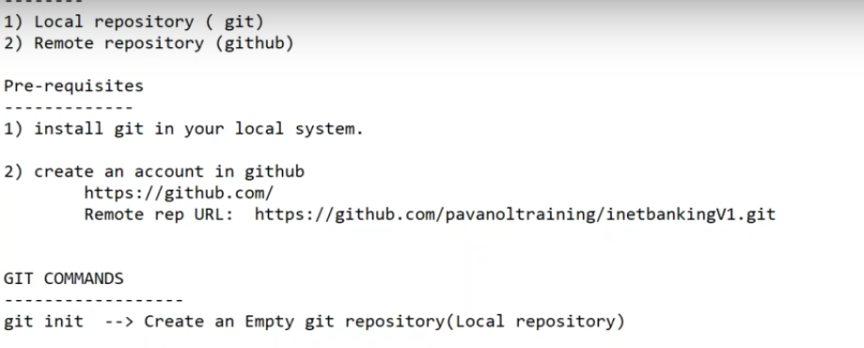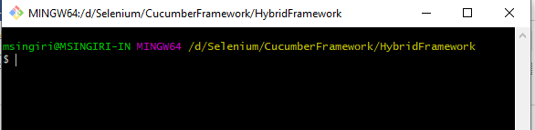

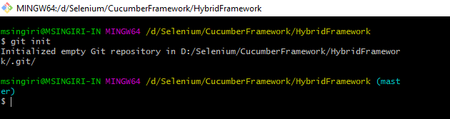

Local repository will create in the location but internally we can’t see that



Get status

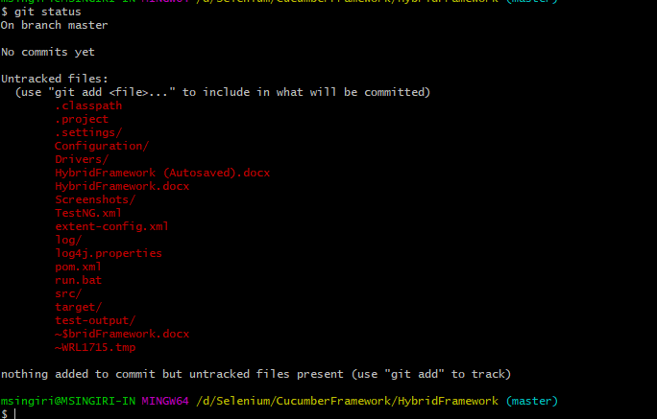

Troubleshooting:

You are running on a JRE rather than JDK?

